Name: Mriganka Patra
Email: mriganka.patra@cognizant.com
Emp ID: 2415820

Day 18
Sprint 1 Submission

Objective: Implement the base CRM logic with record types, automation, visibility settings, and user management.

Task 1.1: As an admin I want to define record types for Accounts based on regions so that data can be segmented accordingly.

a. Go to Setup >

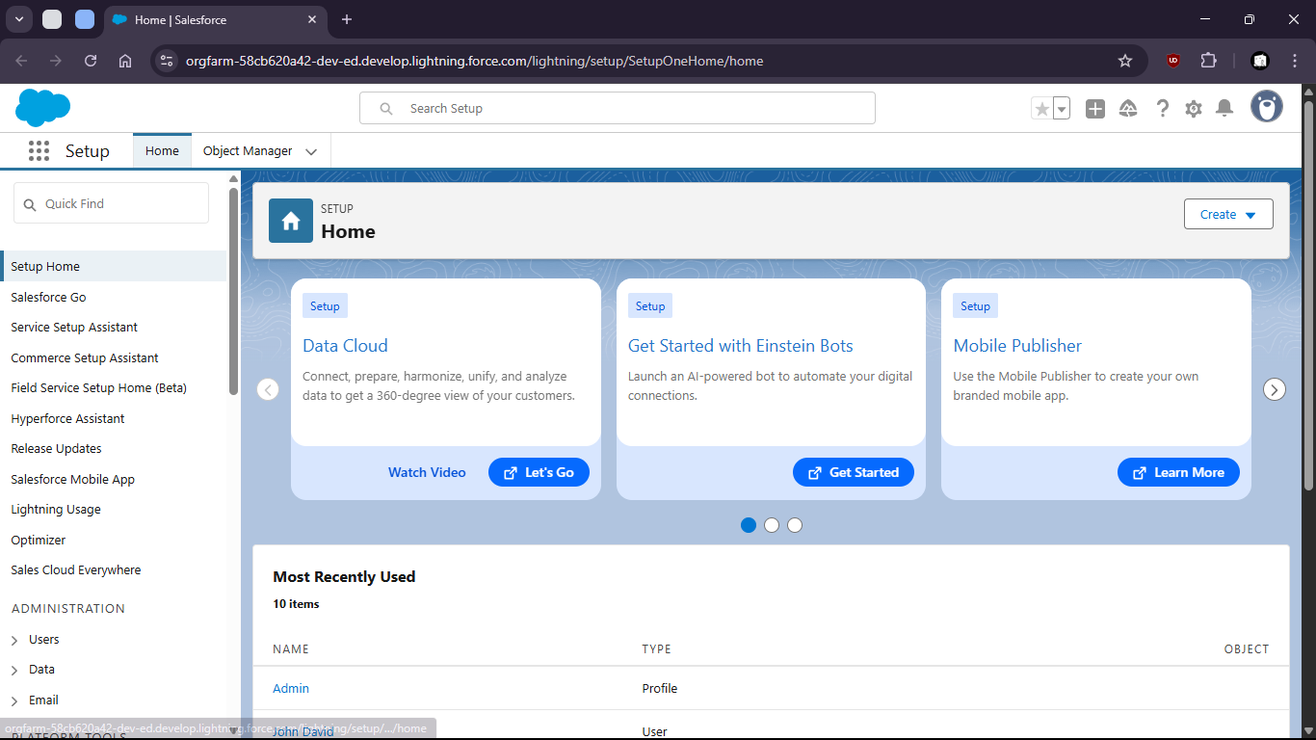
b. go to Object Manager

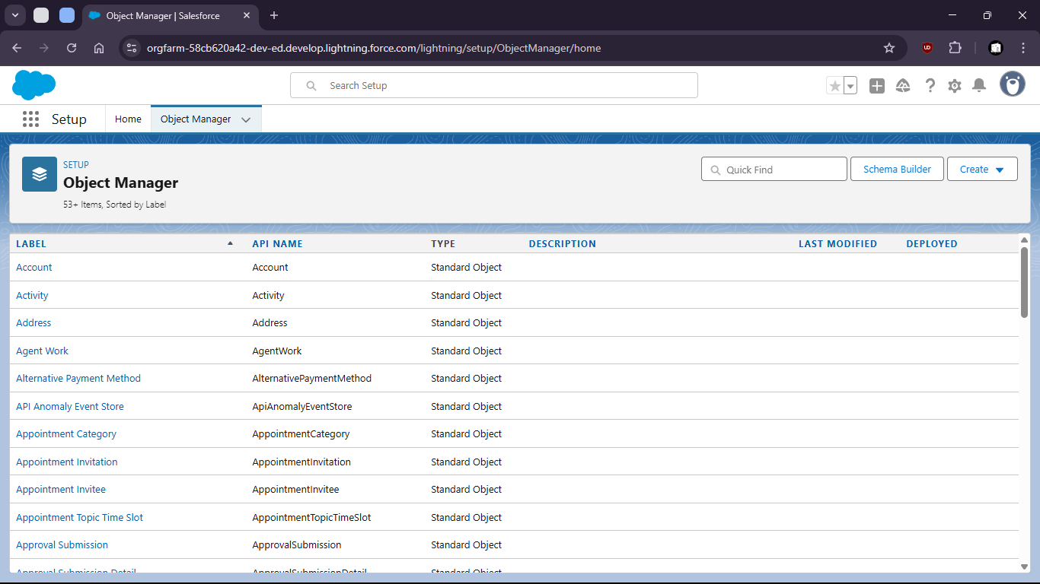

c. Select Account object

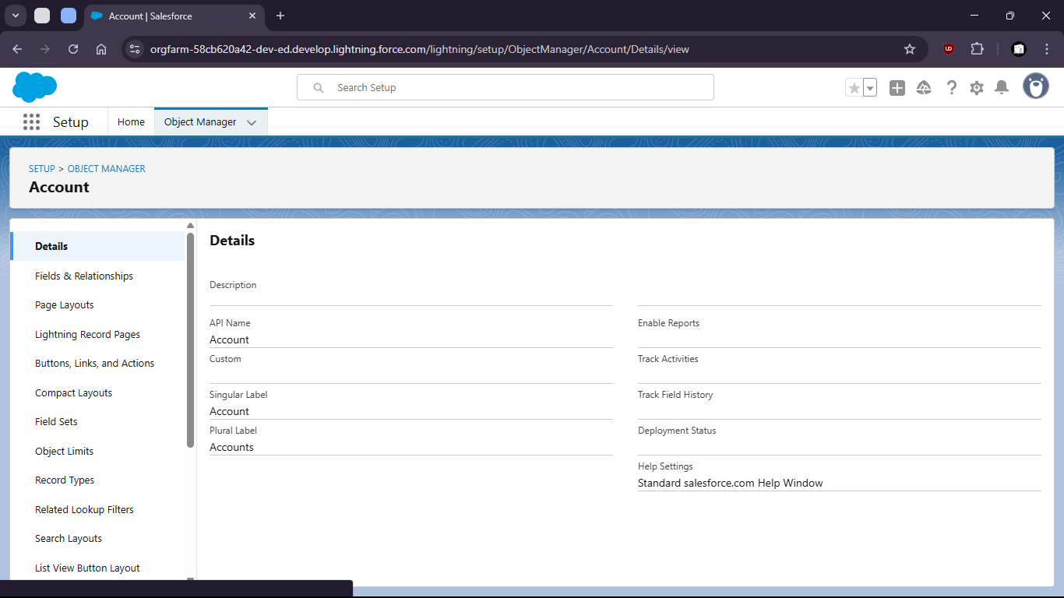

d. select Record Types

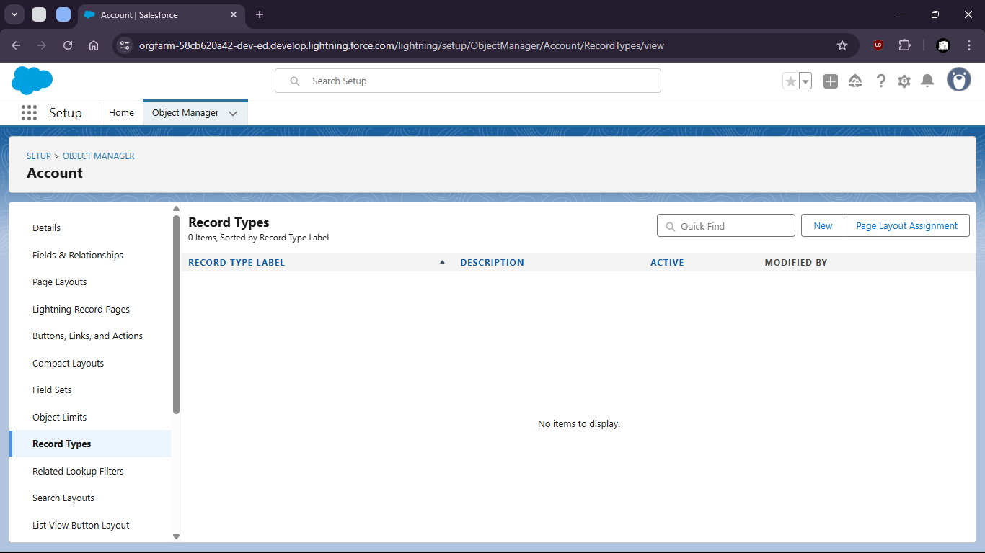

e. create new Record Type for Kolkata people and give permission to admin

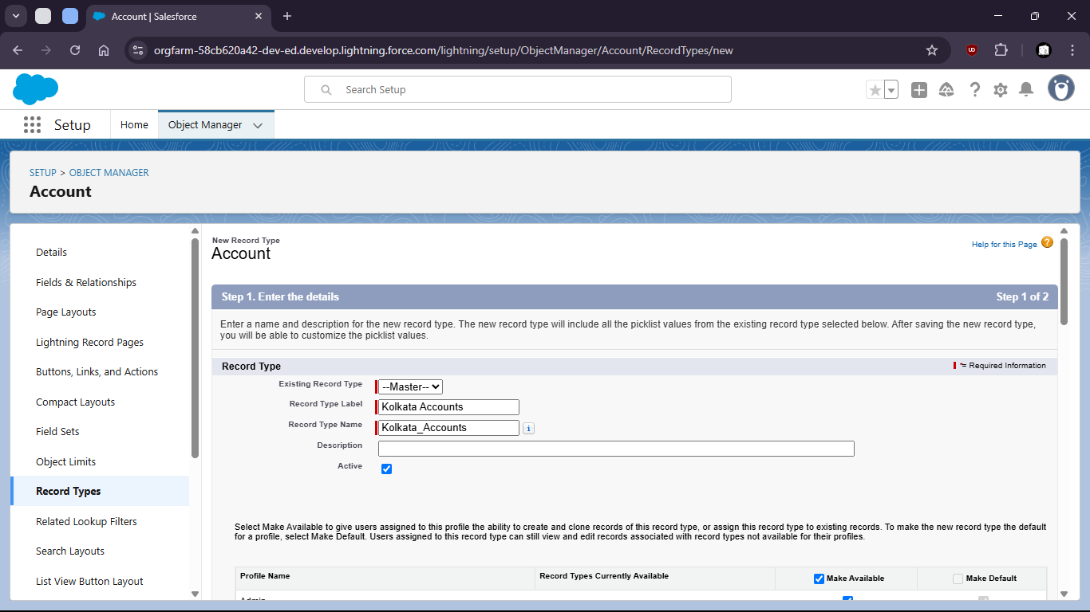

f. give permission

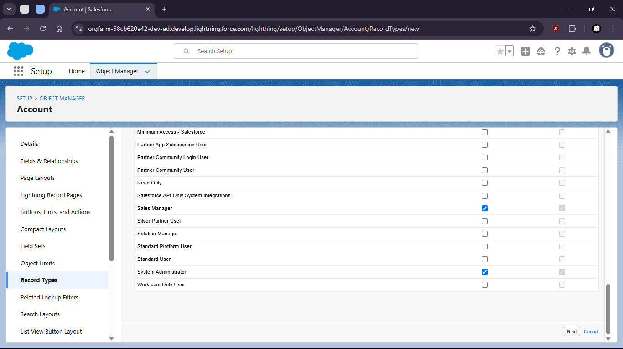

g. set page layout

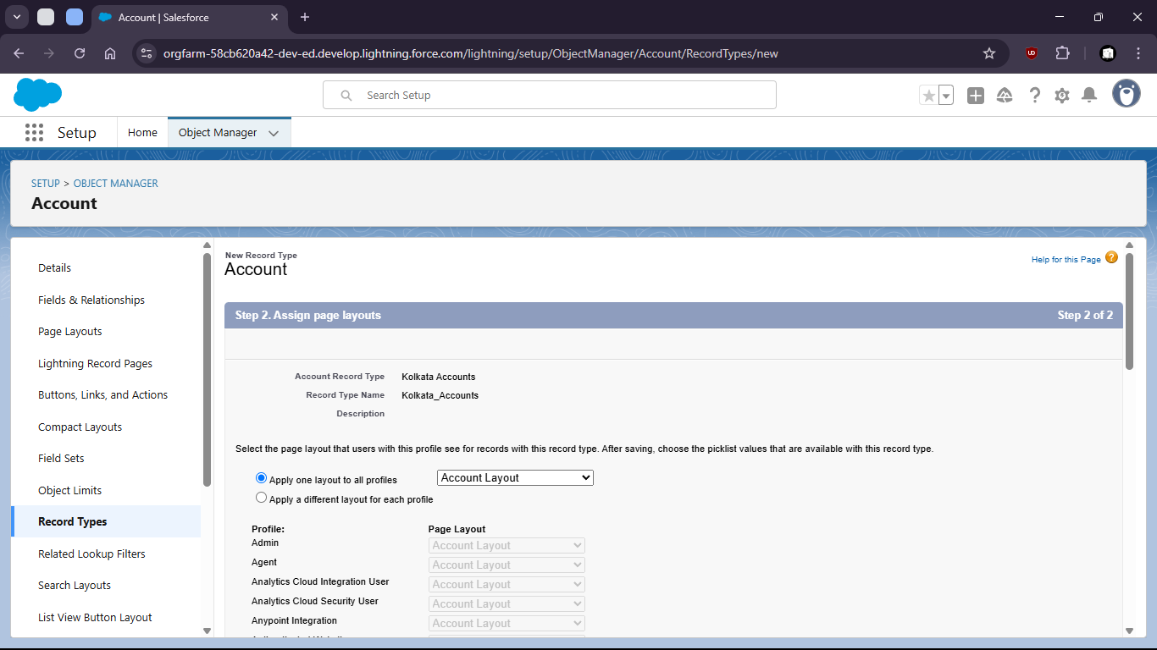

h. Select save and new

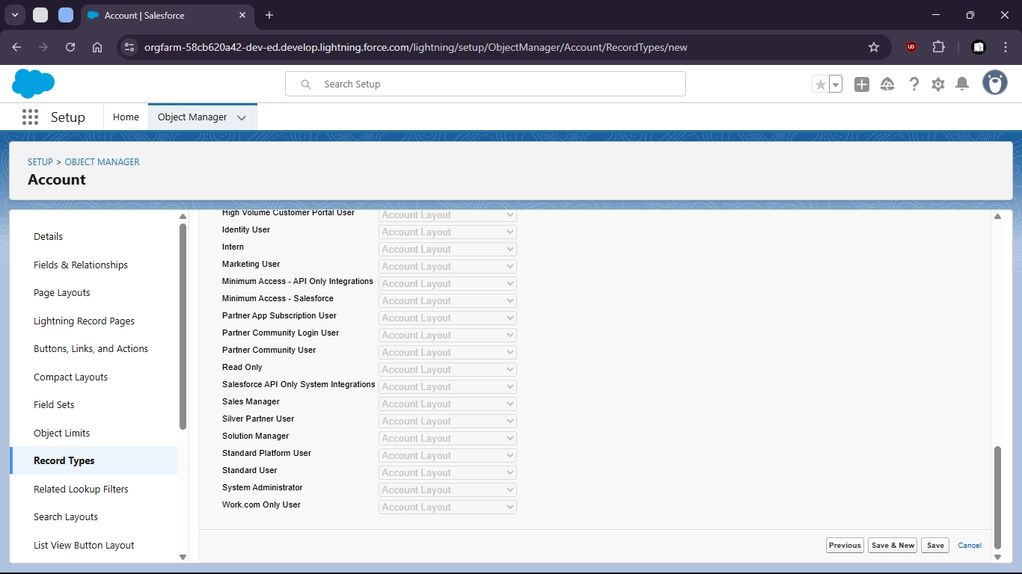

i. create another for Delhi region

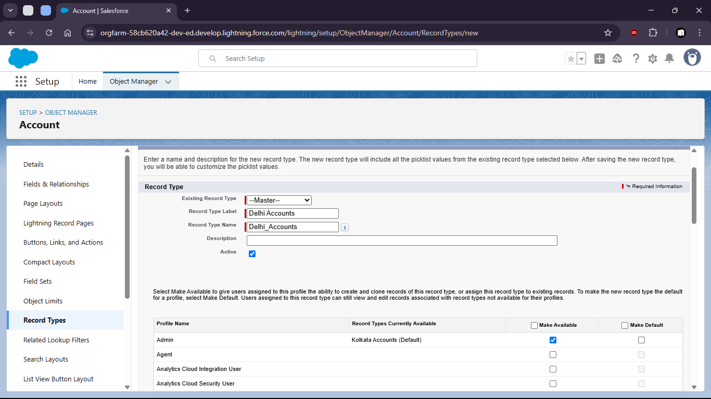

j. Give permissions to profiles

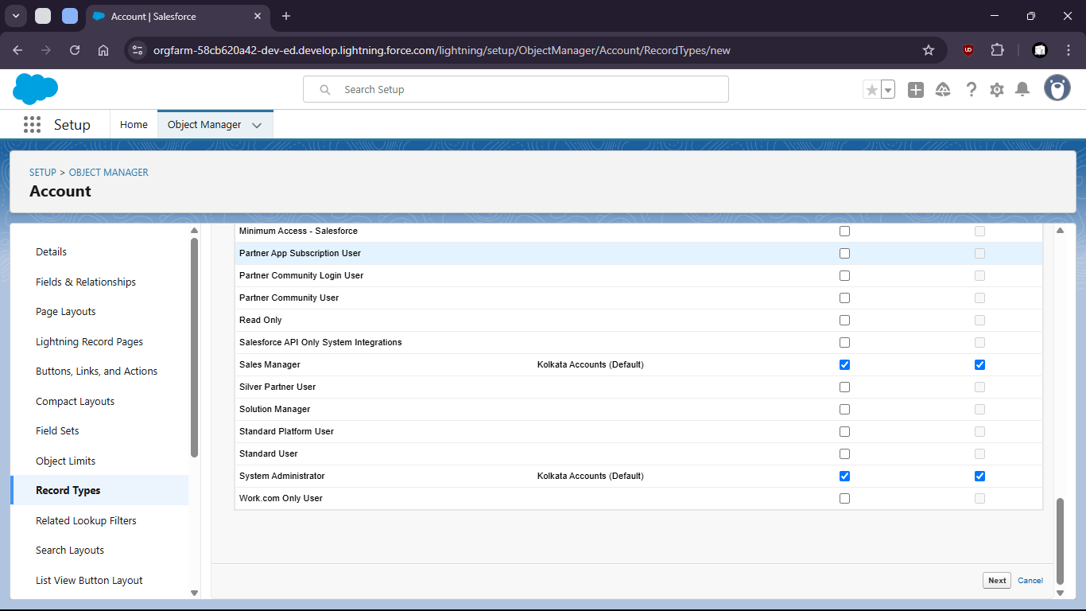

k. Set layout

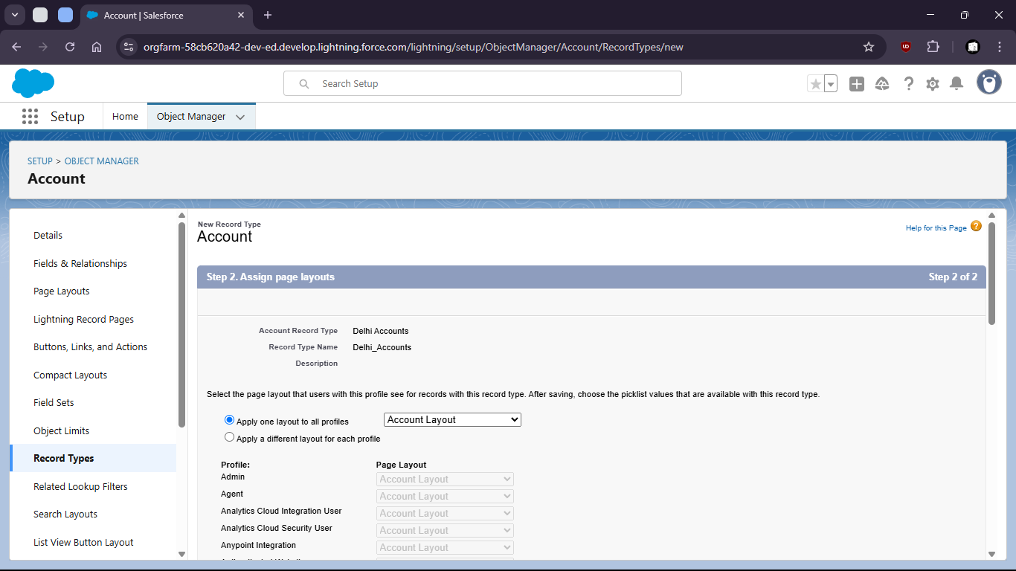

l. Save



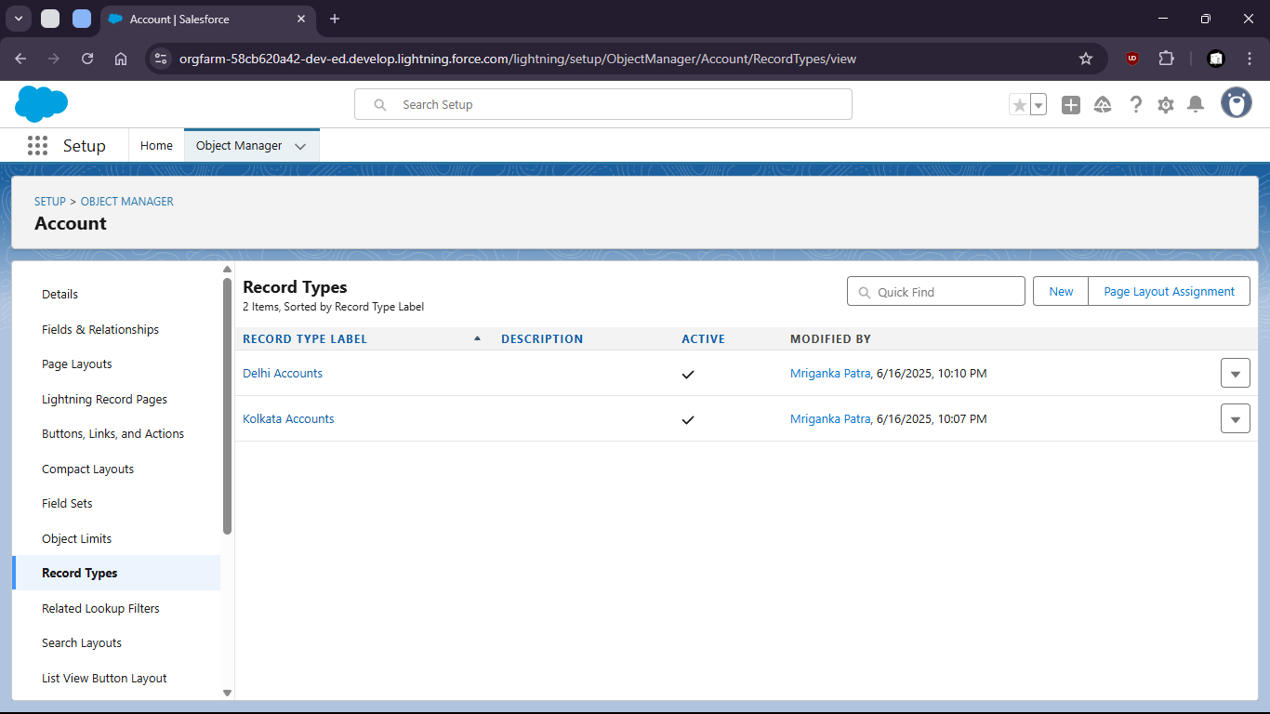

Task 1.2: As a CRM user, I want to see the age of a contact calculated from their birthday so that I can segment users by age group.

- Go to object Manager

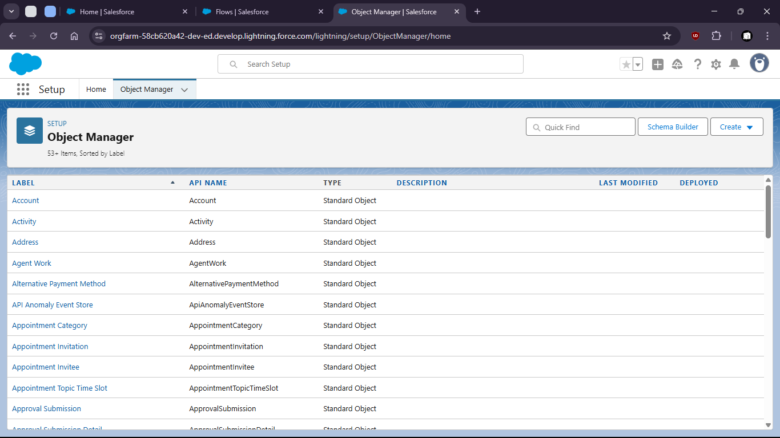

- Select Contact object

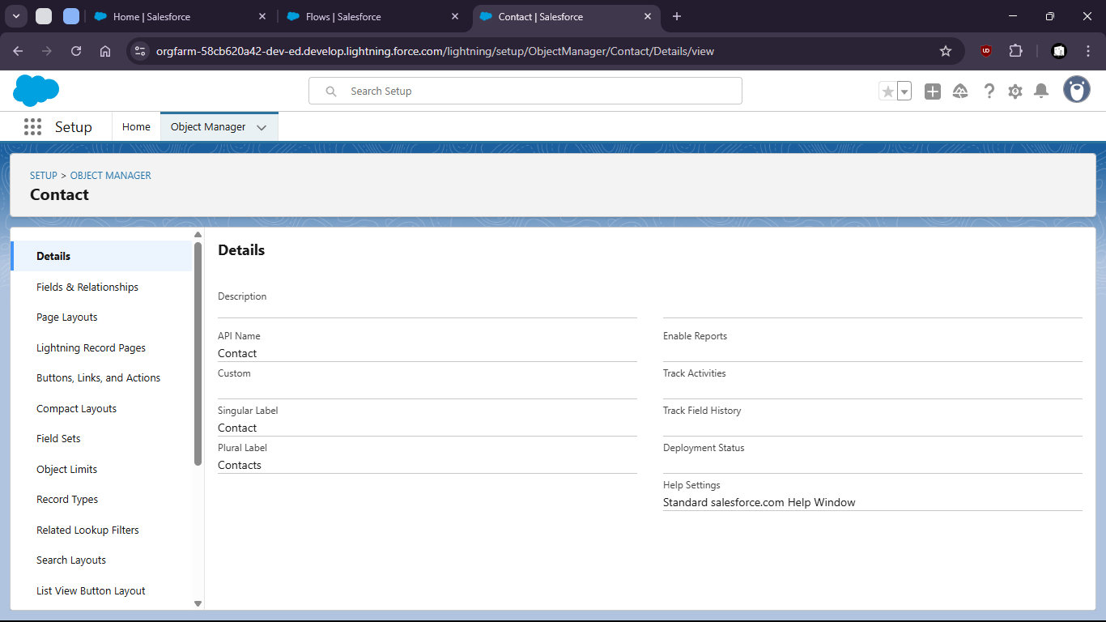

- Go to the fields and relationships

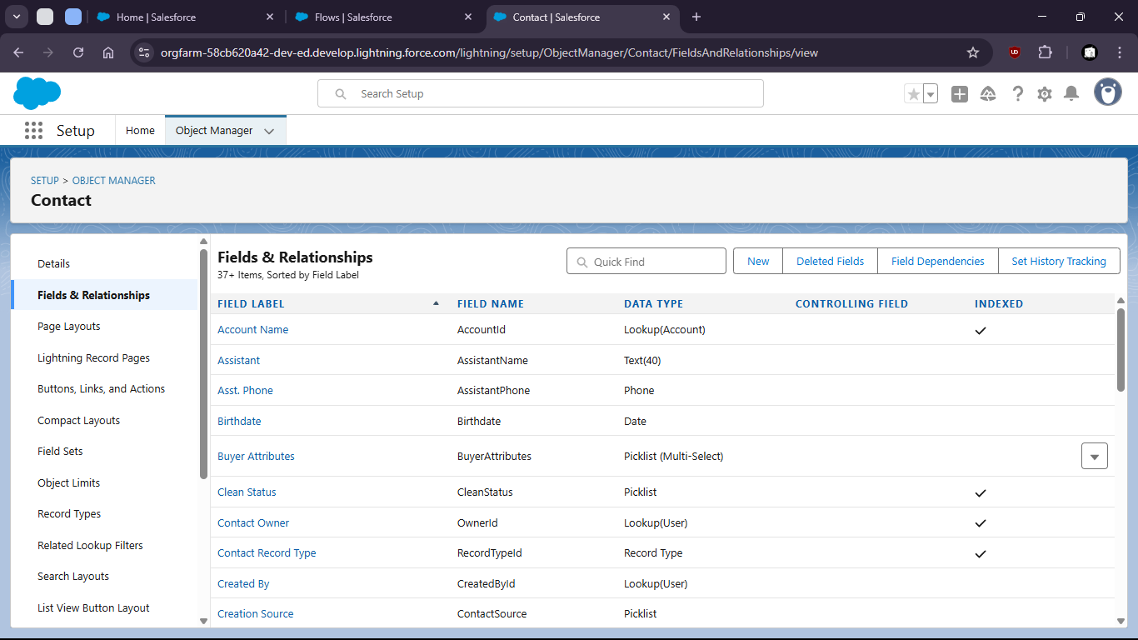
- Create a new Field as Formula

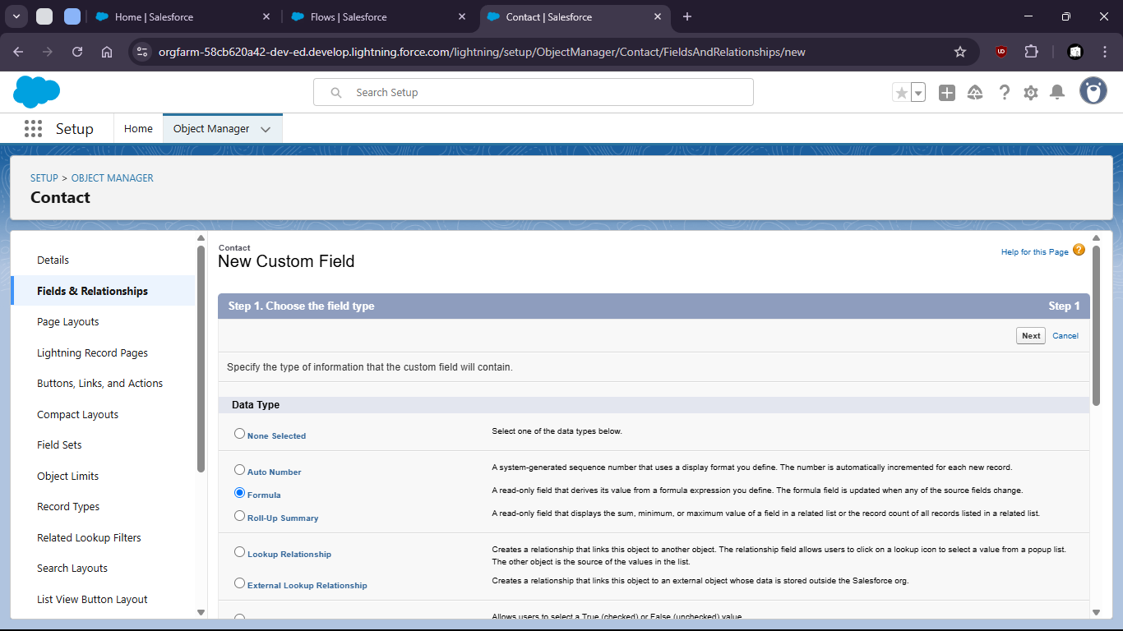

- Give name and type

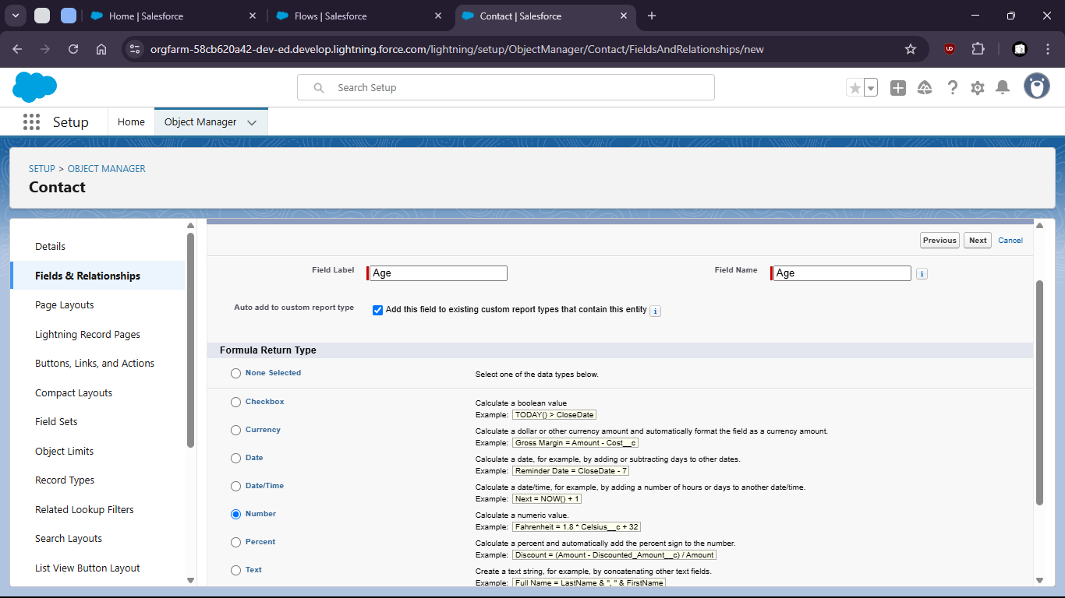

- Enter the formula with proper syntax

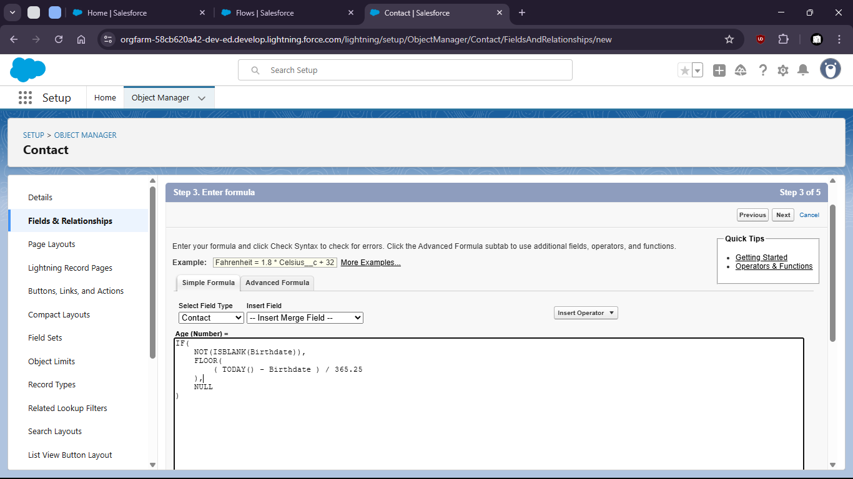

- Setup field level security and save

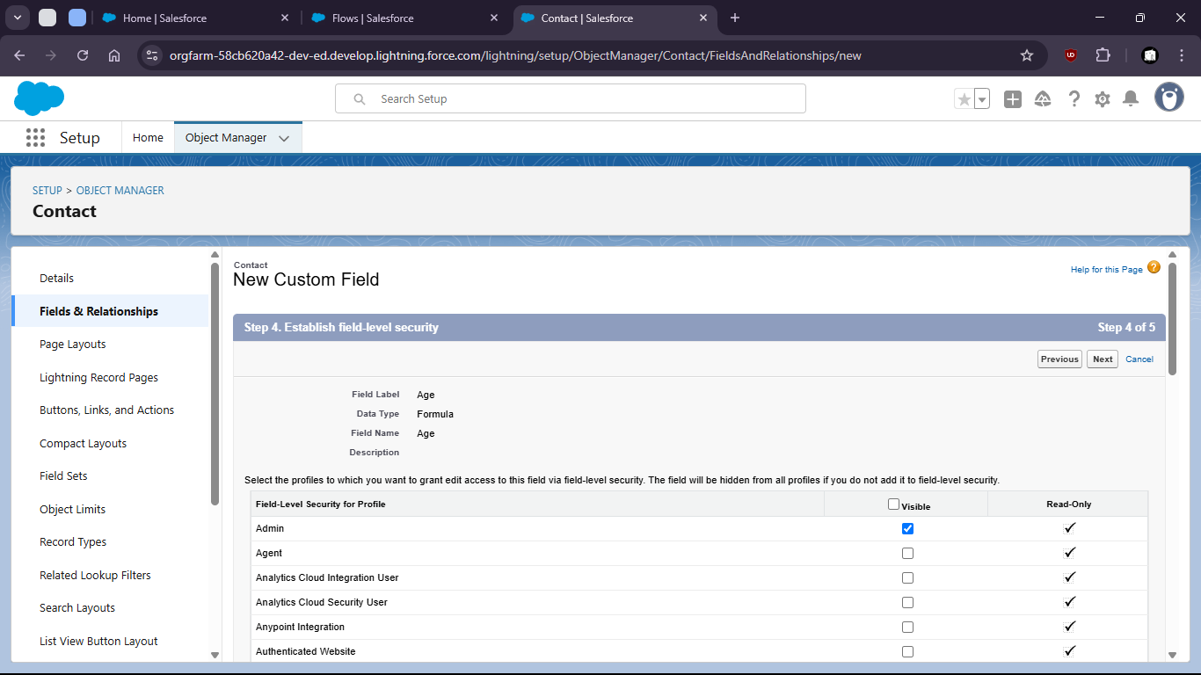

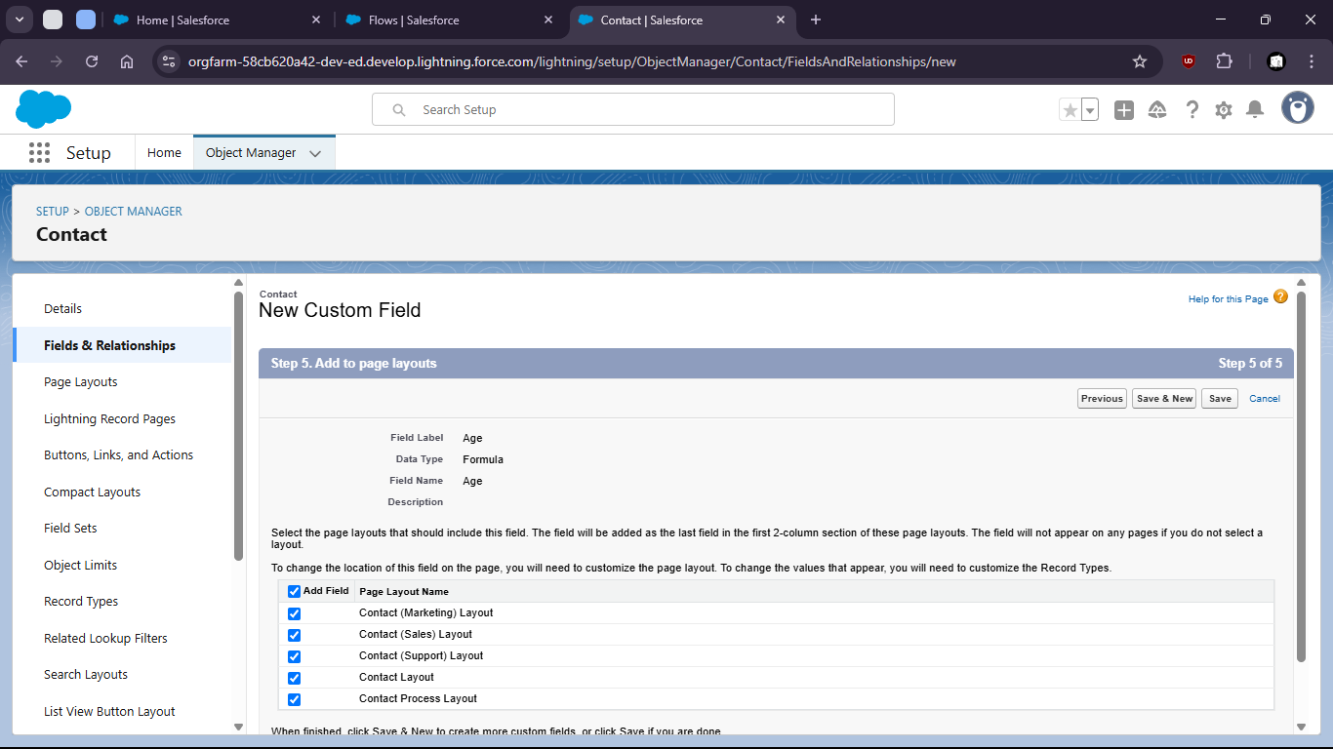

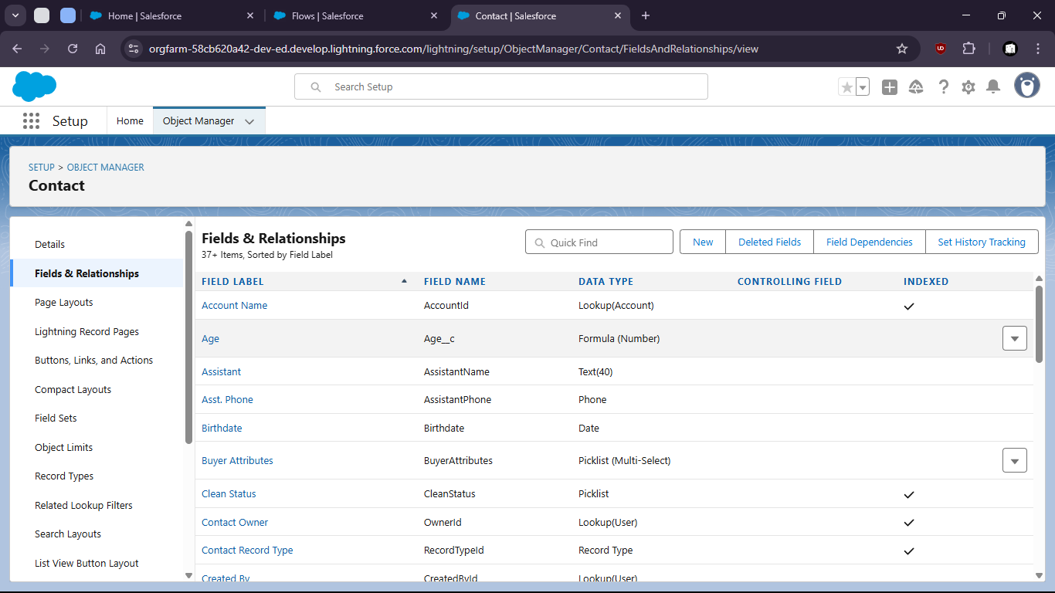

- Now verify the field is working or not.

- Go to contacts > create new contacts

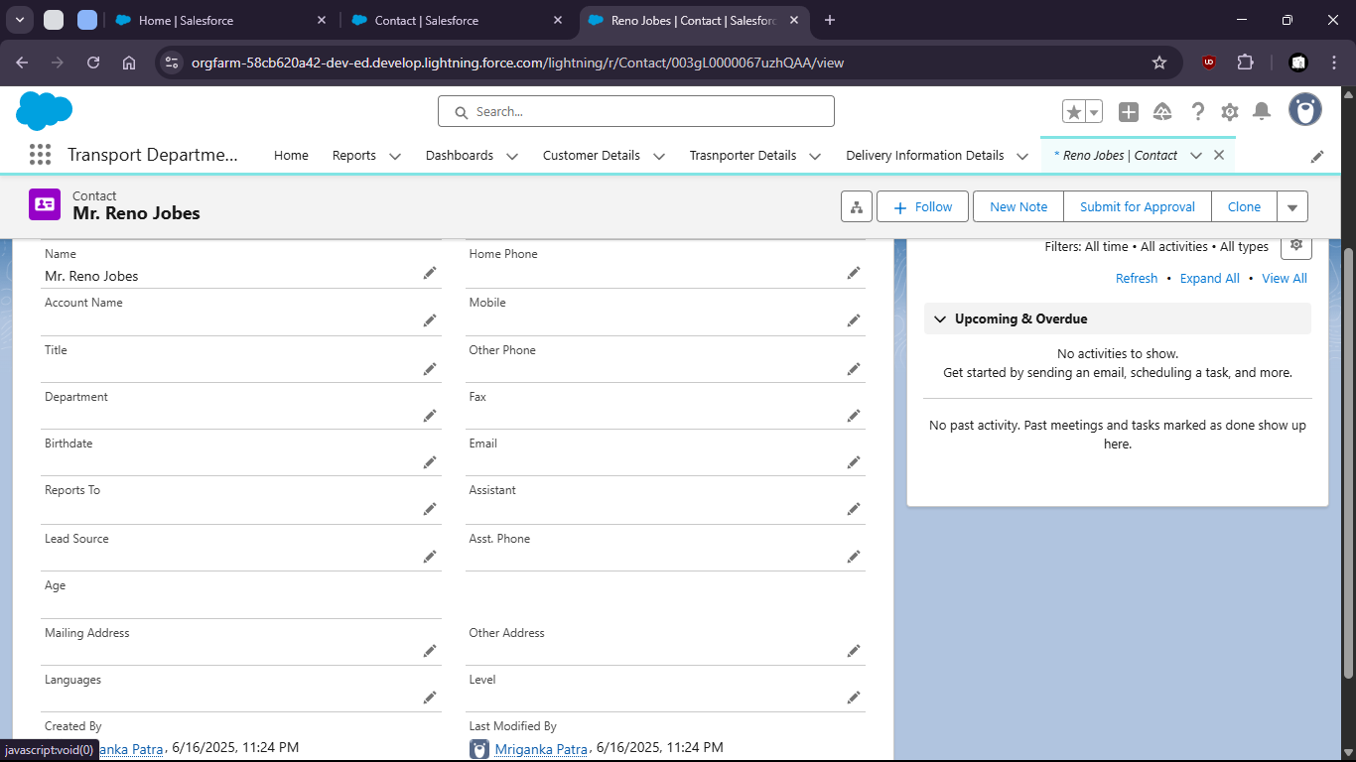
- When no Birthdate given the age shows empty (NULL)

- But when we put a Birthdate the age is calculated

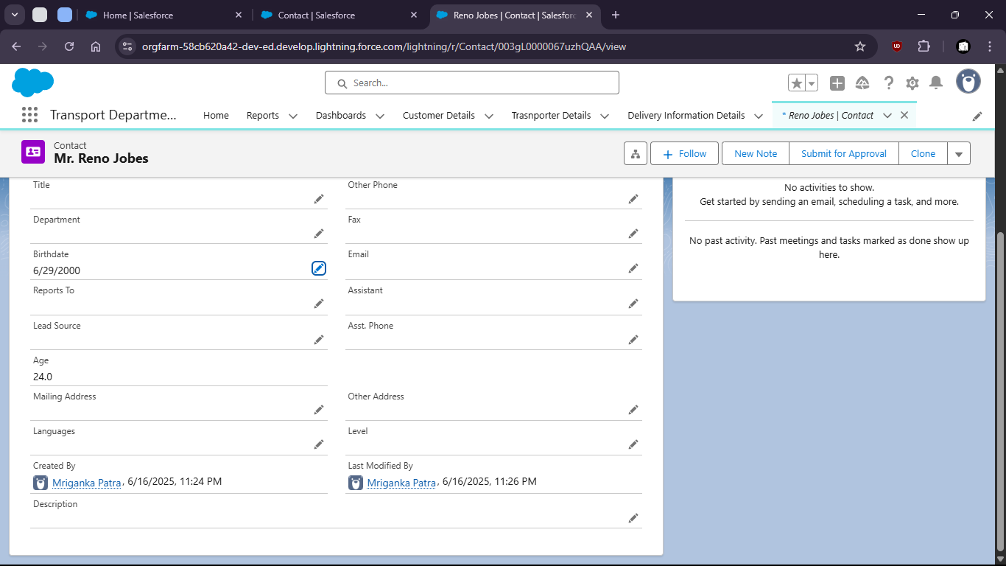

Task 1.3: As an admin, I want to create Users with specific access levels so that only autorized roles can access or edit data.

- Goto setup > home

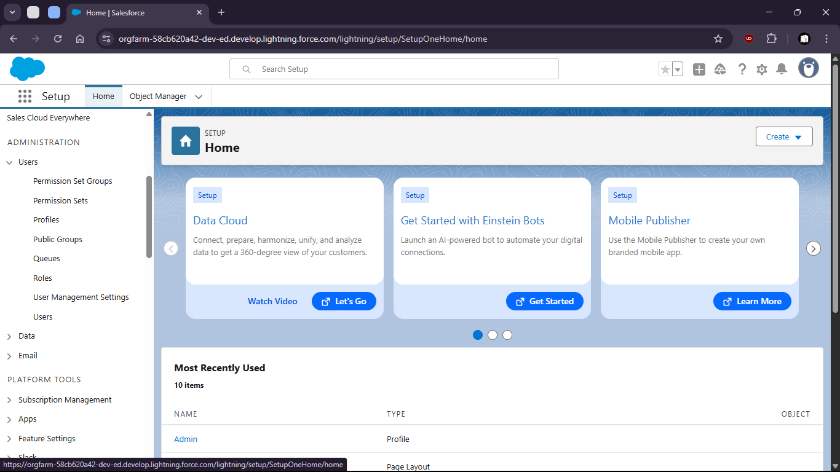

- Open profiles and create profiles

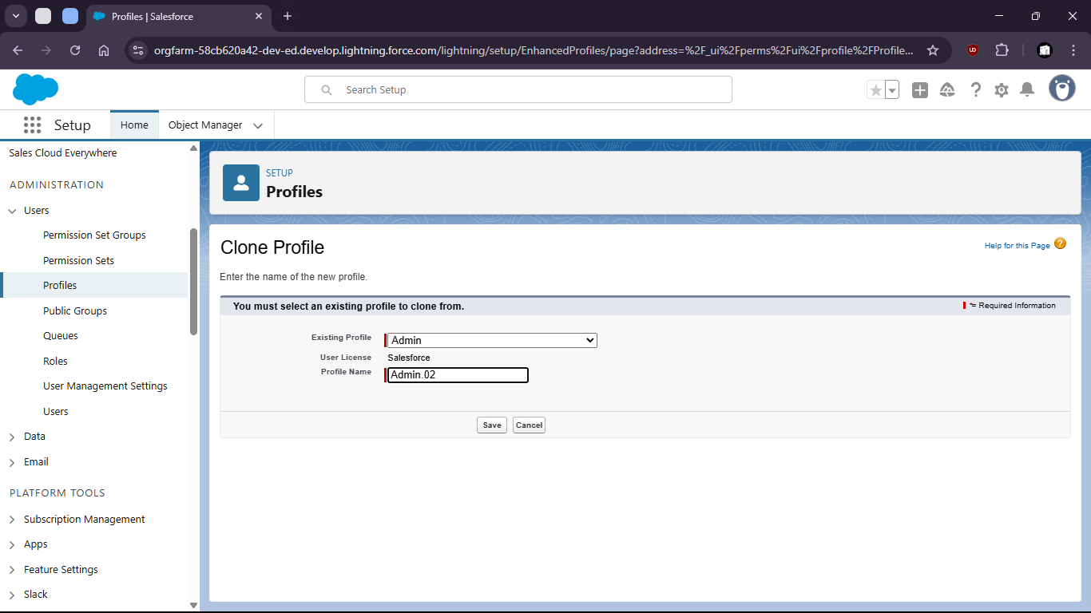

- Limit Access (field level security)

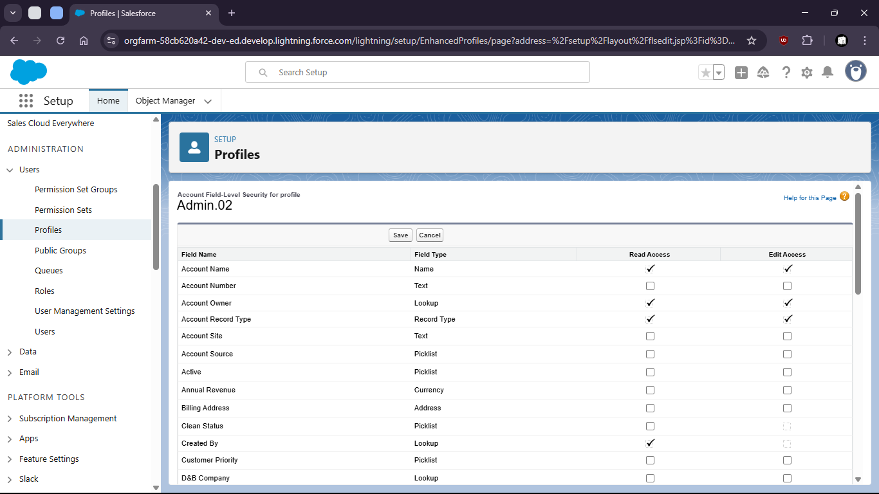
- Set standard object Permissions

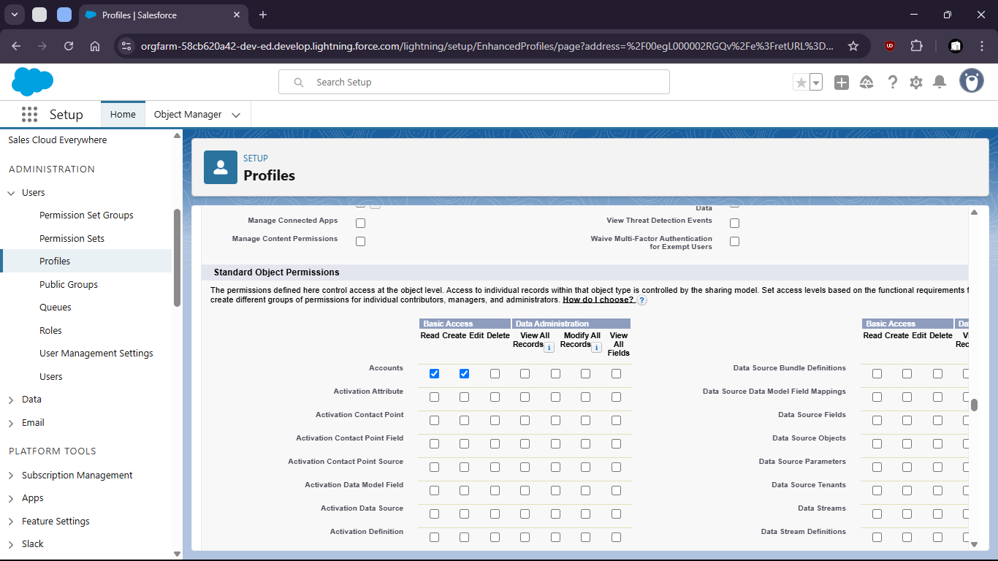

- Add to permission sets

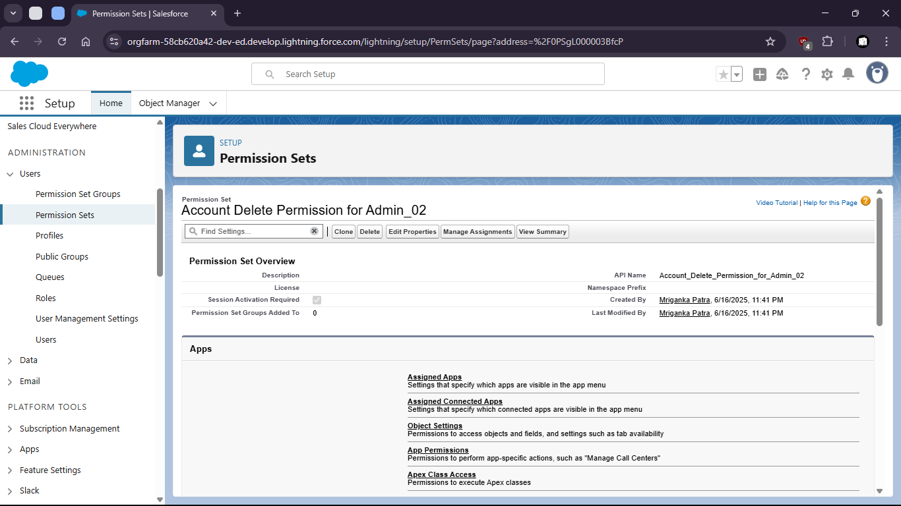
- Change object settings

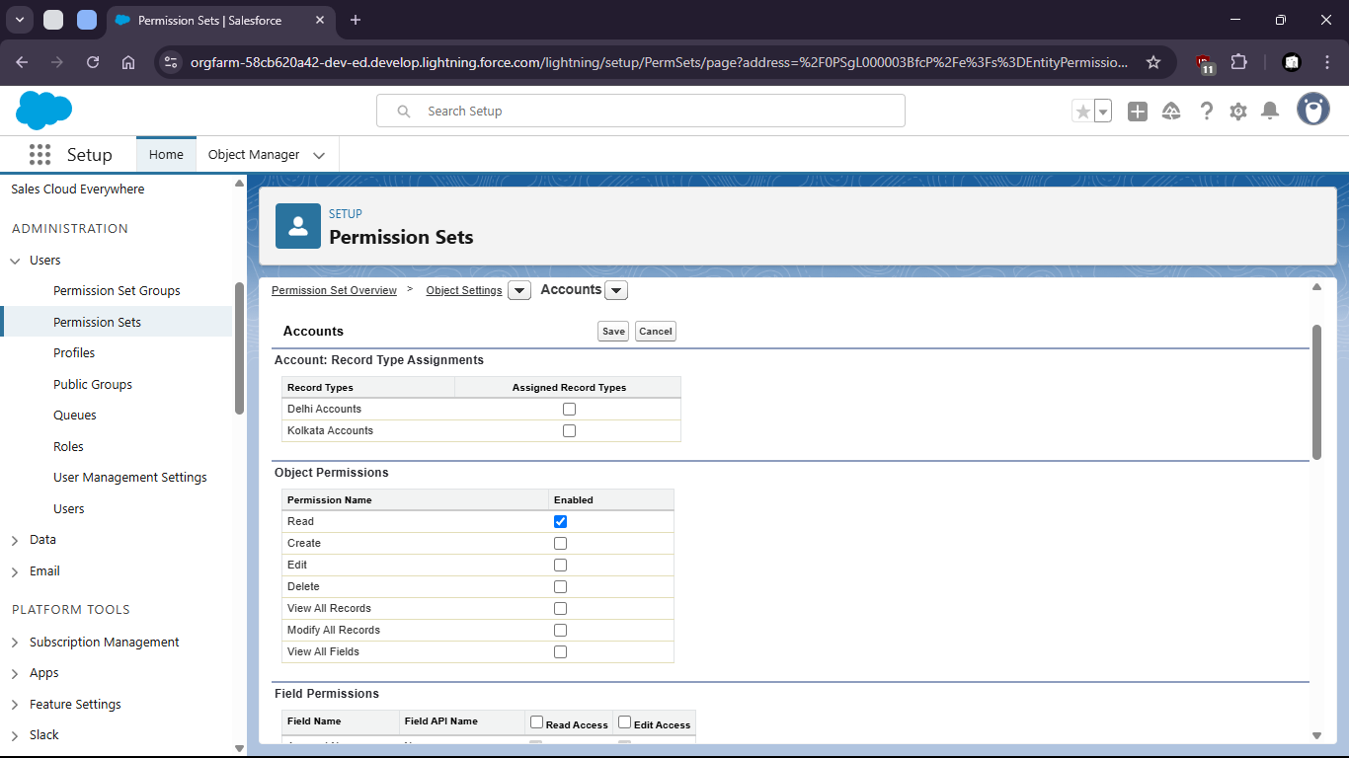
- Create new User

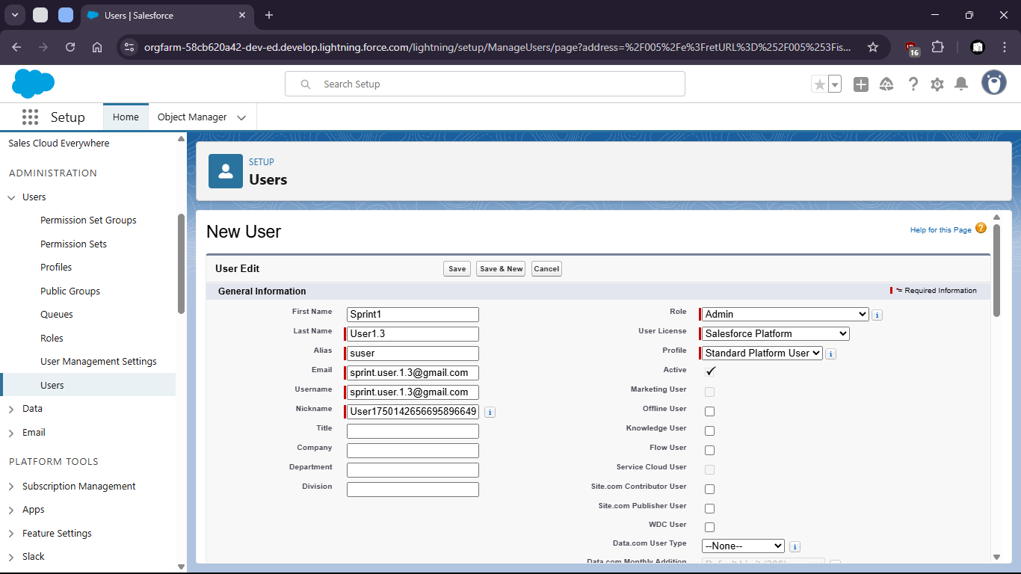
- Assign user to Permission sets

- Assigning User to Roles can also limit access levels

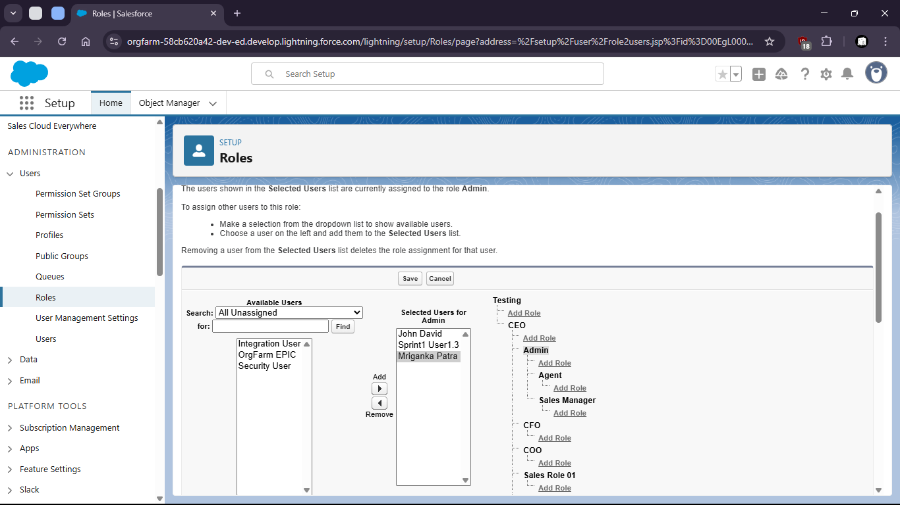
- Where the access is restricted to upper levels

Task 1.4: As an admin I want to set visibility rules for data so that users only see records relevant to their role.

- Go to setup > home
- Search for sharing settings

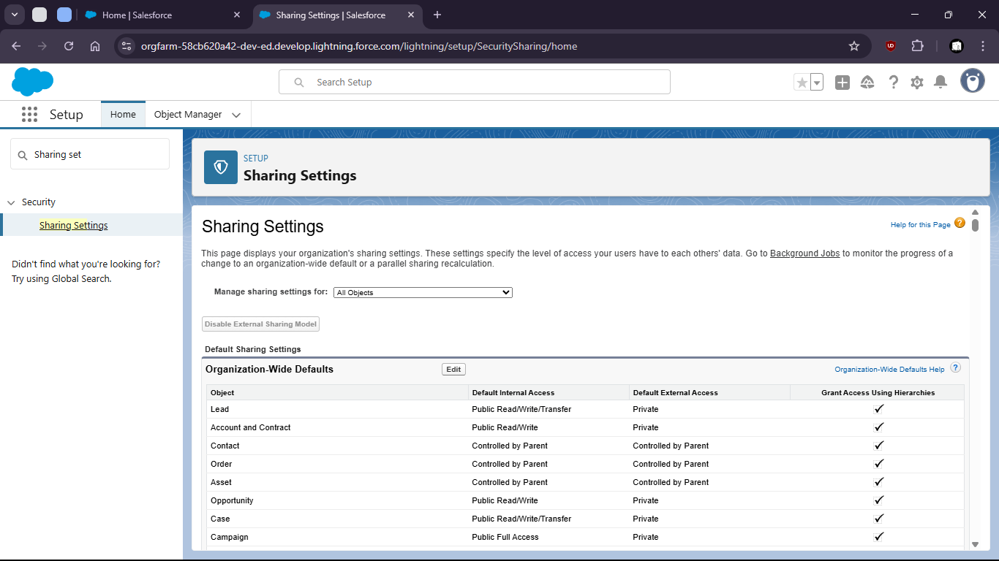

- Make changes to org wise defaults

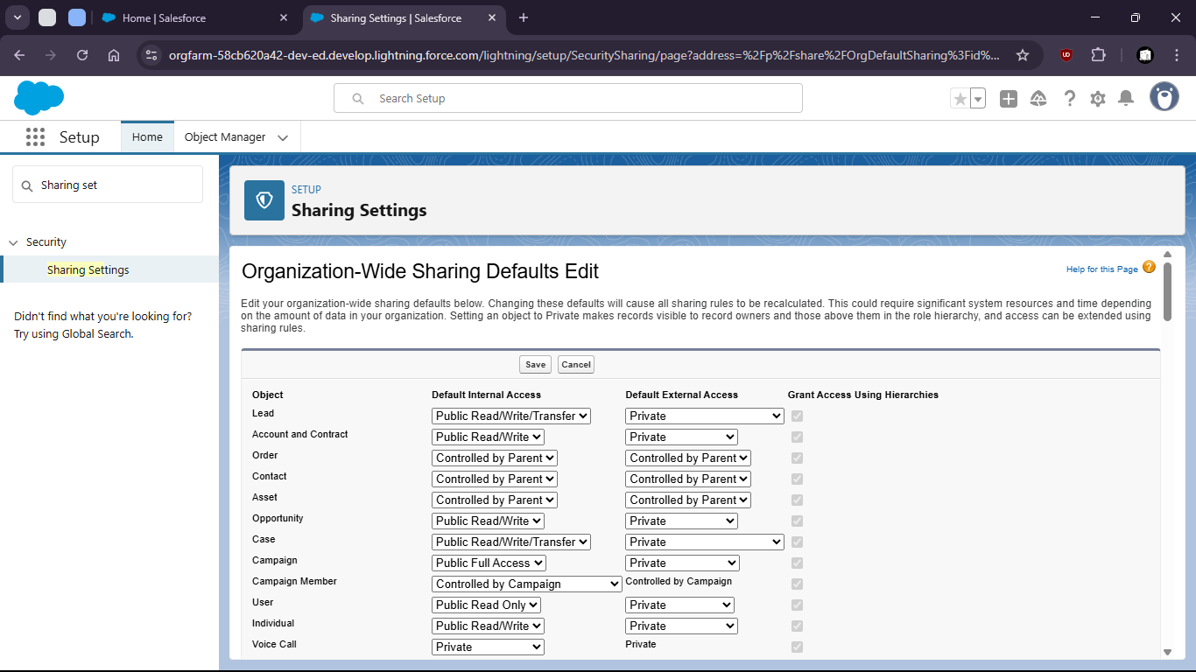

- Now goto home > Roles

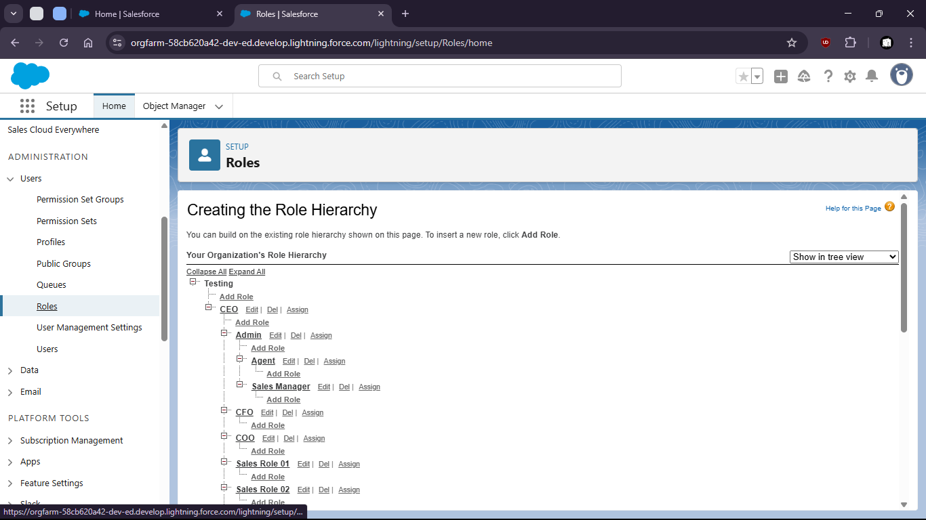

- Set up roles under CEO as Admin

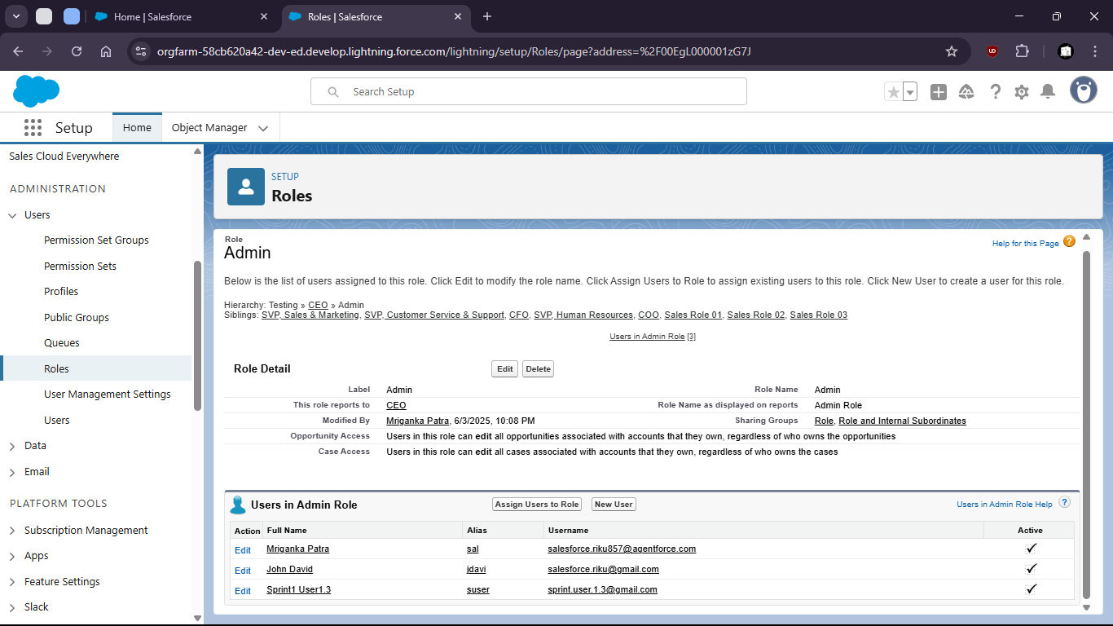

- Look for assigned users to this role

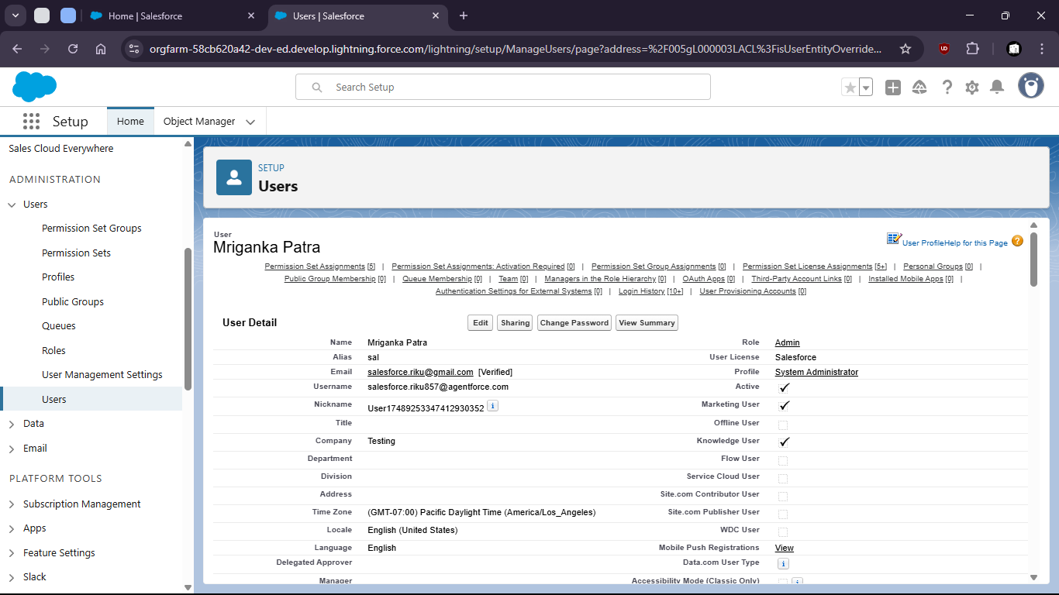

- For the assigned users in that Role create a sharing rule

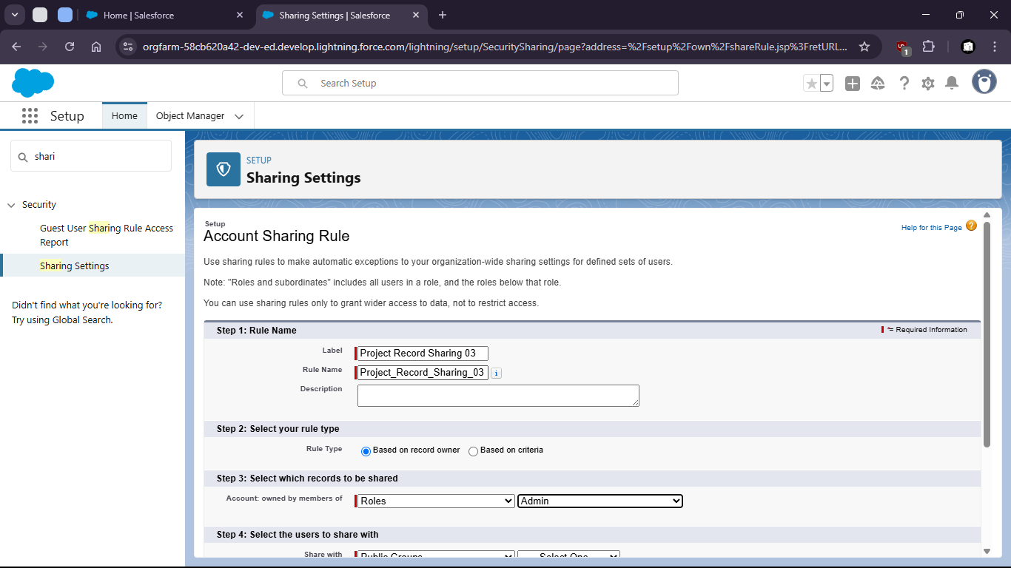

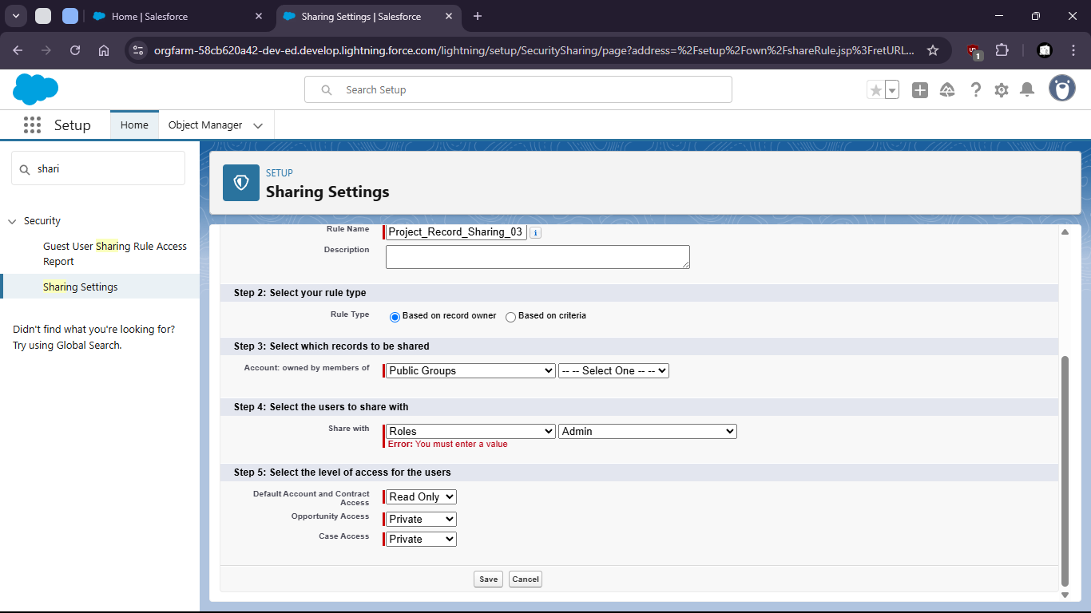
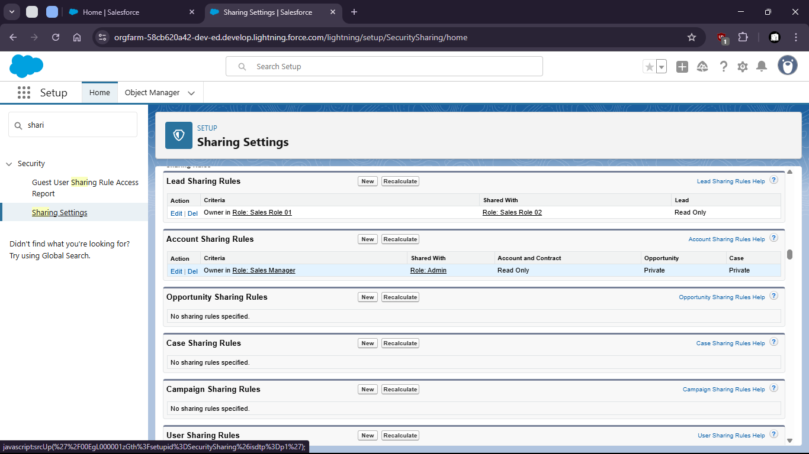

Task 1.5: As a data manager, I want to bulk upload Account records using the data loader so that initial data can be seeded efficiently.

- Go to setup > home
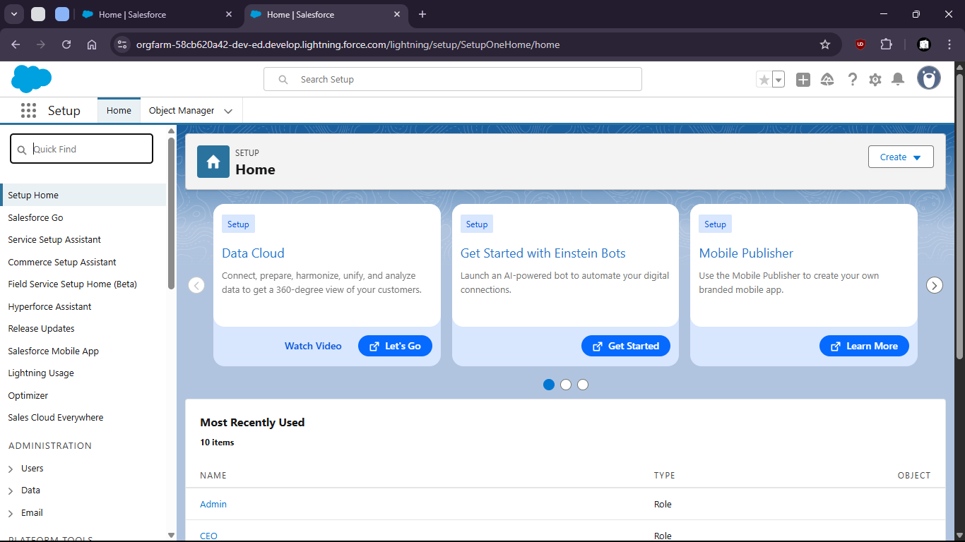

- Search for data import wizard

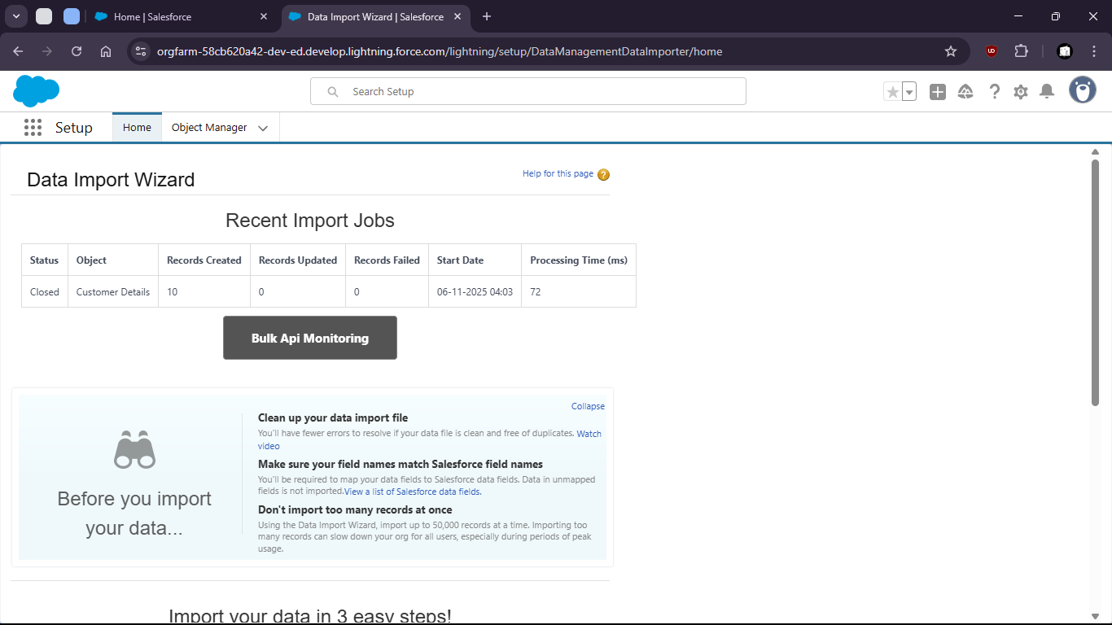

- launch wizard

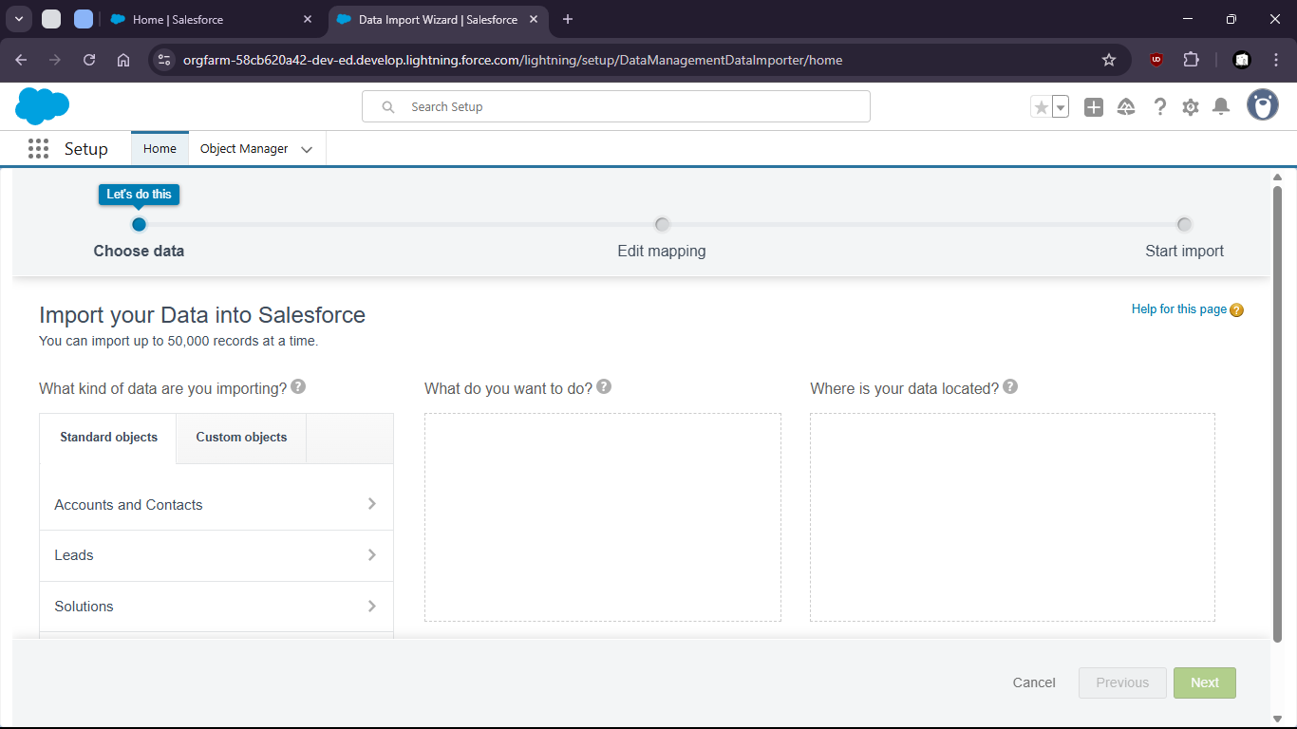

- Select > Custom object > Customer Details > Add new Records > Upload the csv

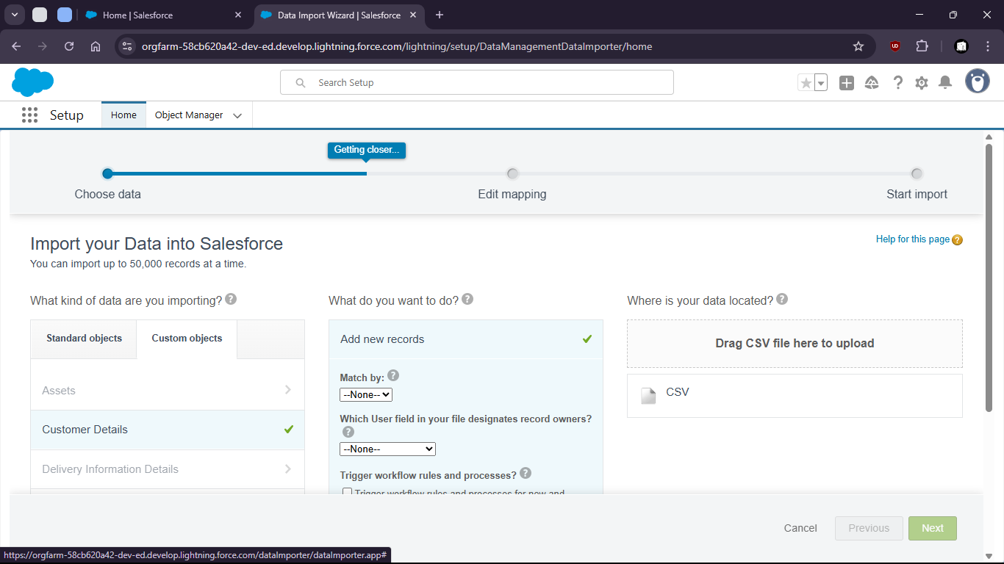

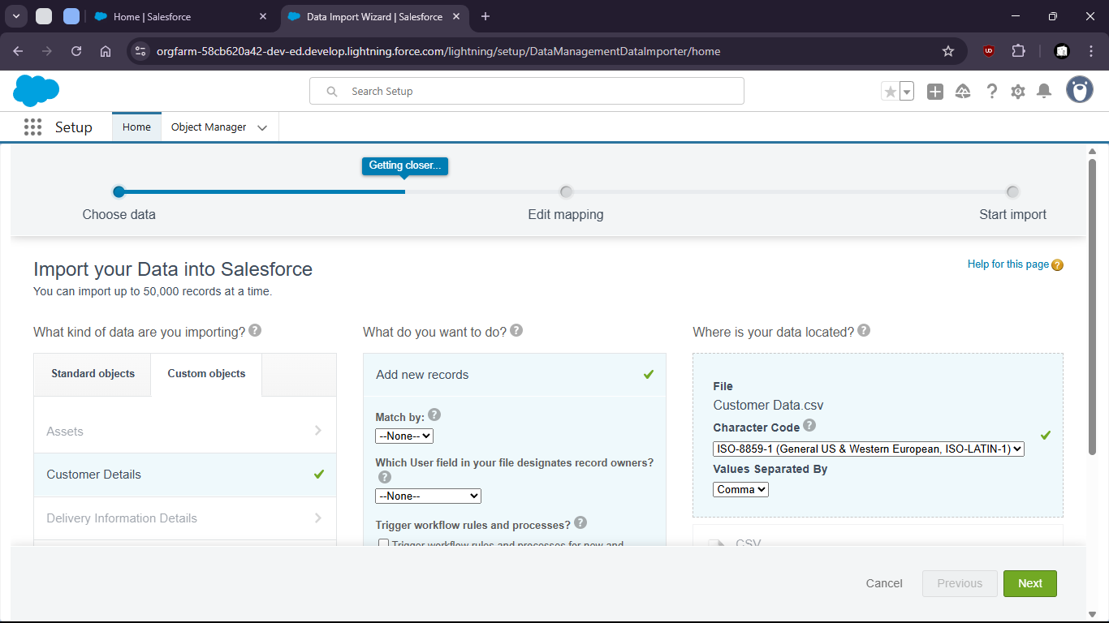

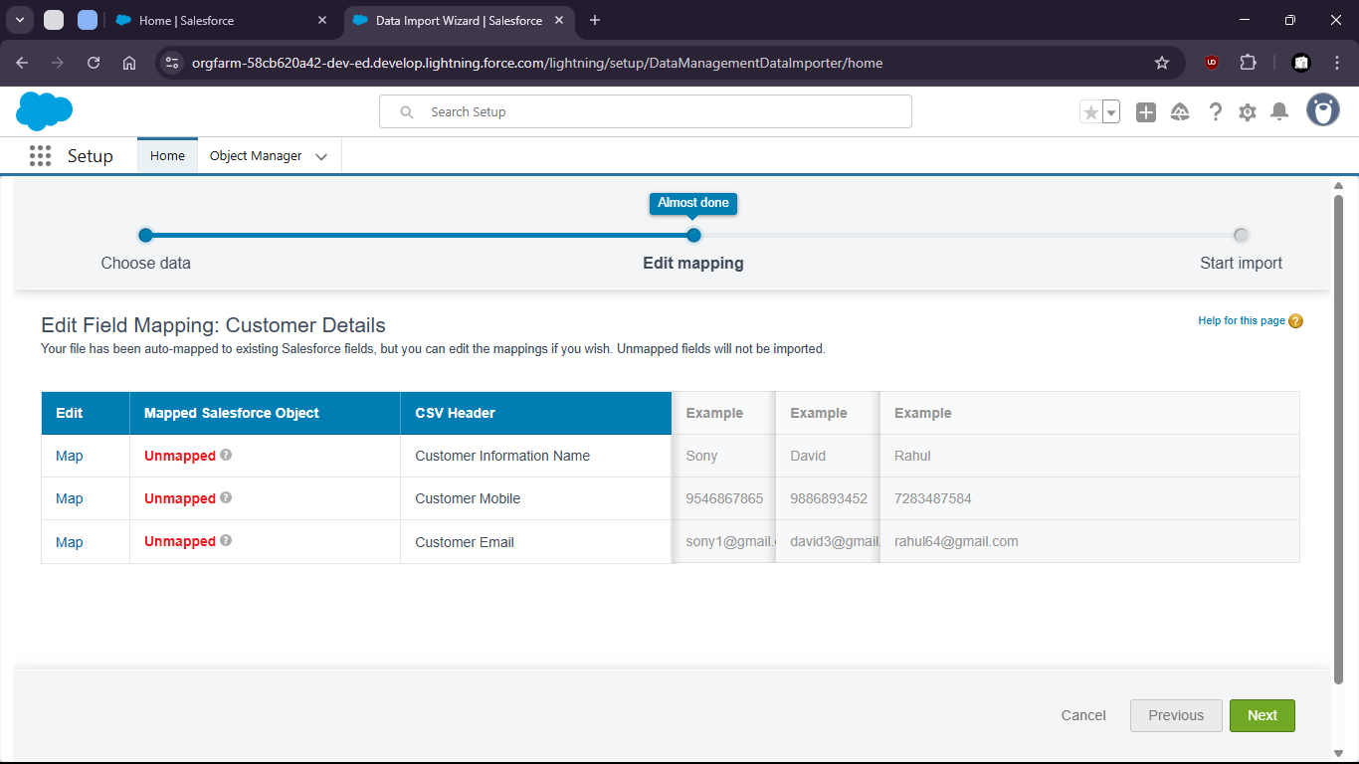
- Now map the fields

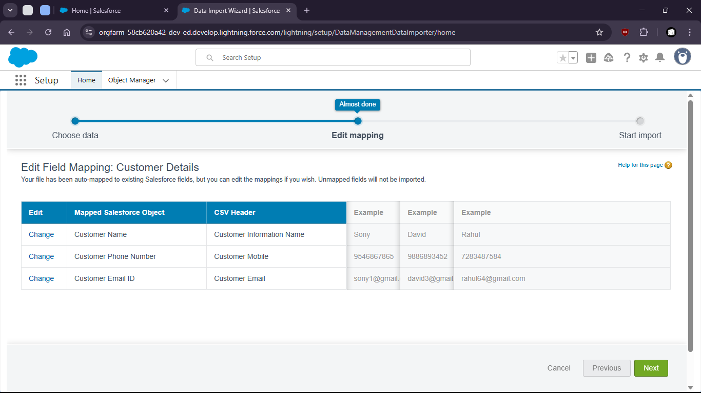

- now start import
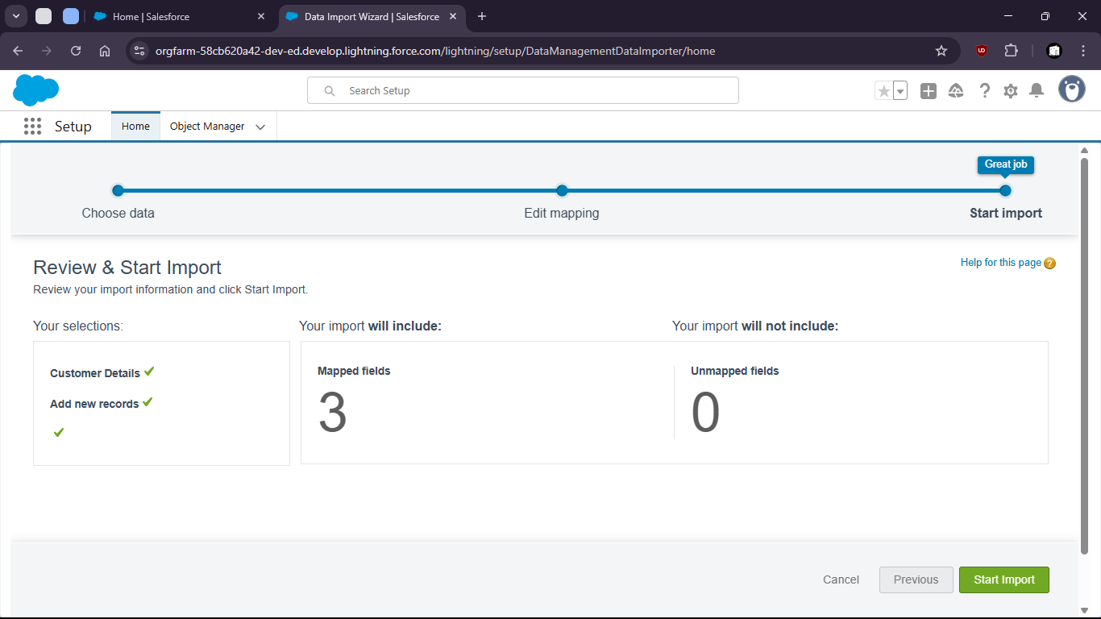

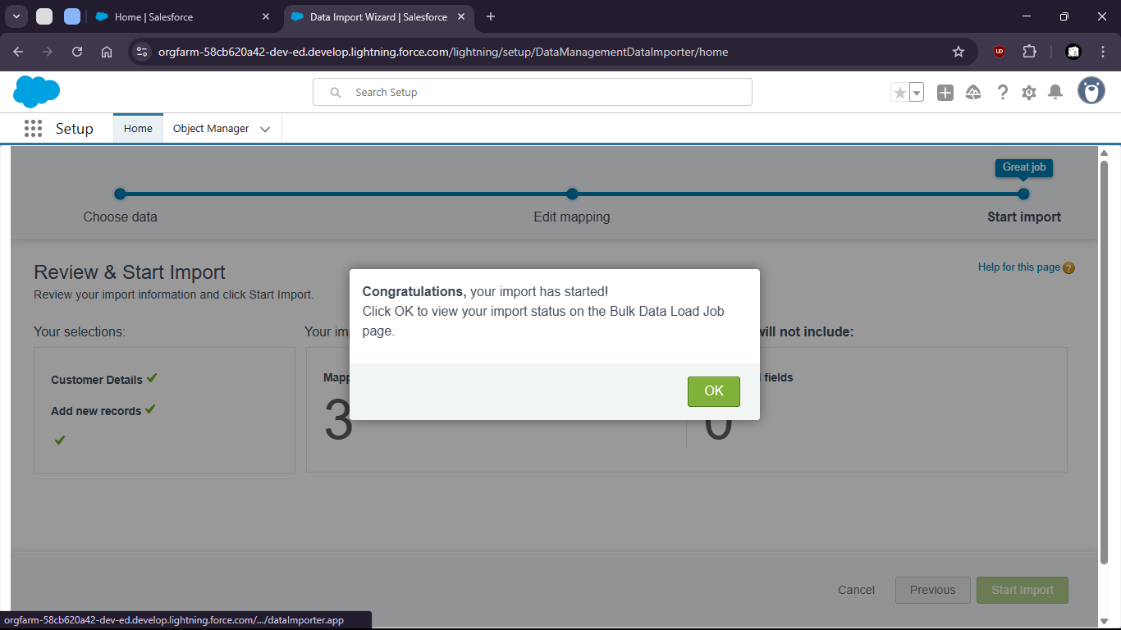

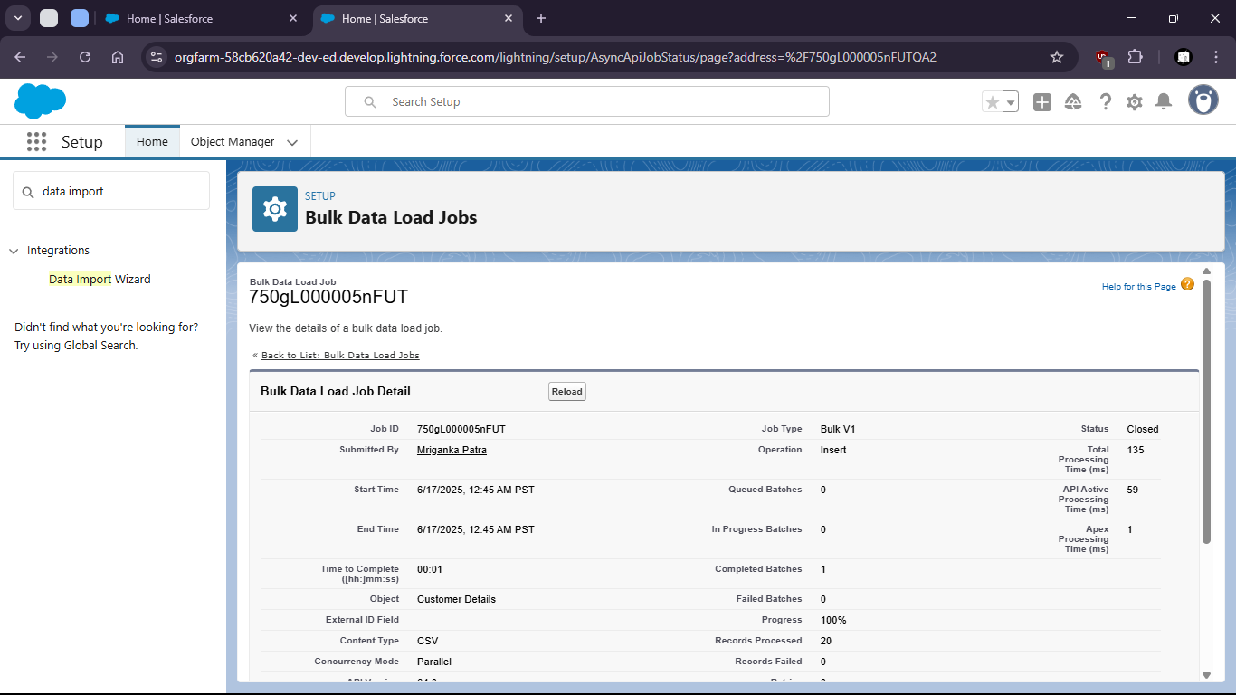

- Now check for all customer details (if upload was successful)

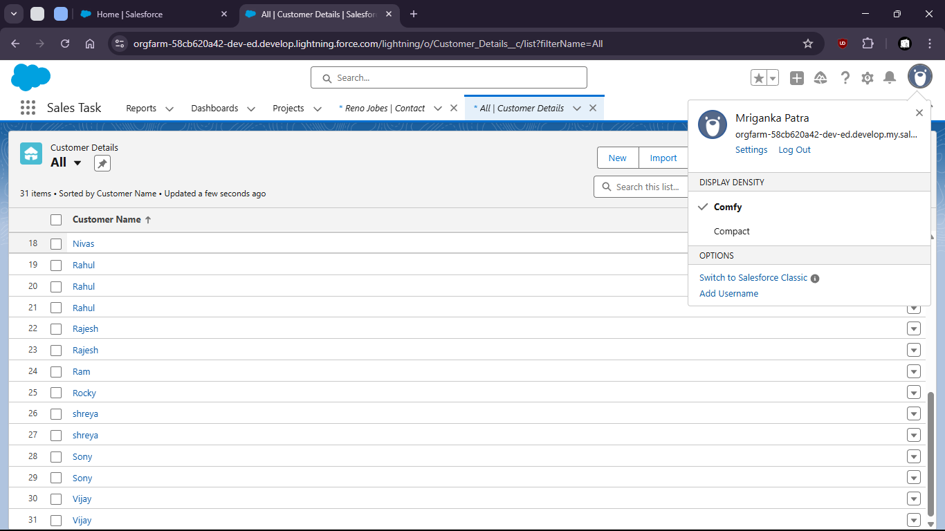
- Uploaded csv file:

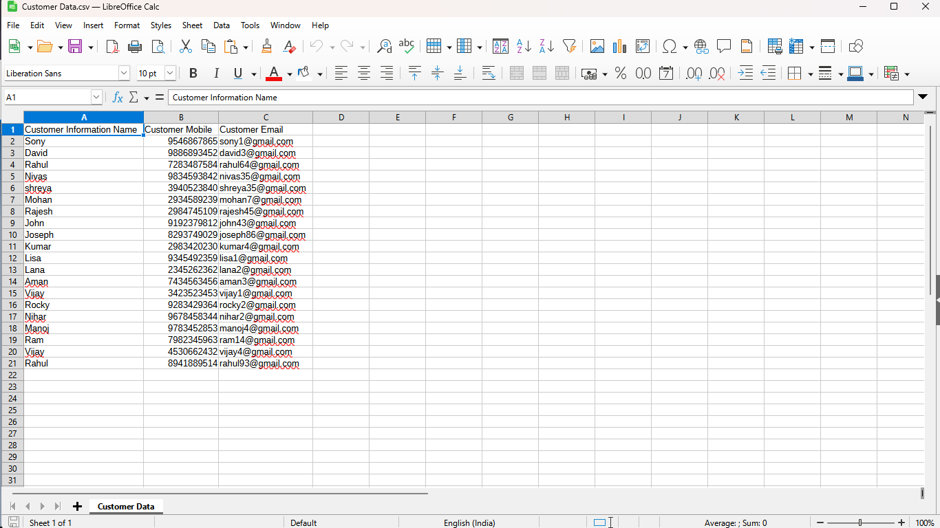

- Validations

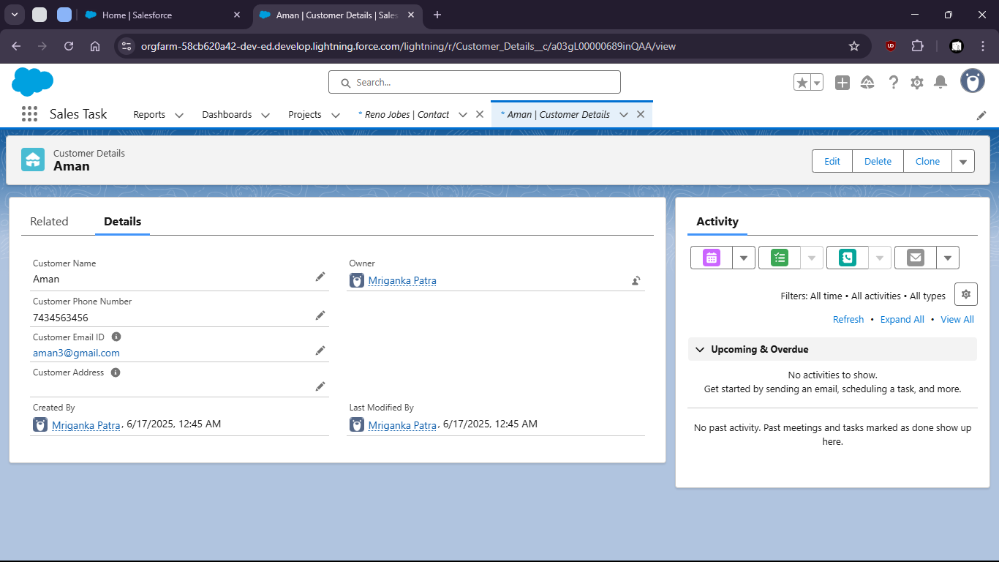

Task 1.6: As a sales manager, I want to auto-create an opportunity when a new Account is added so that sales tracking begins immediately.

- Go to setup > Object Manager

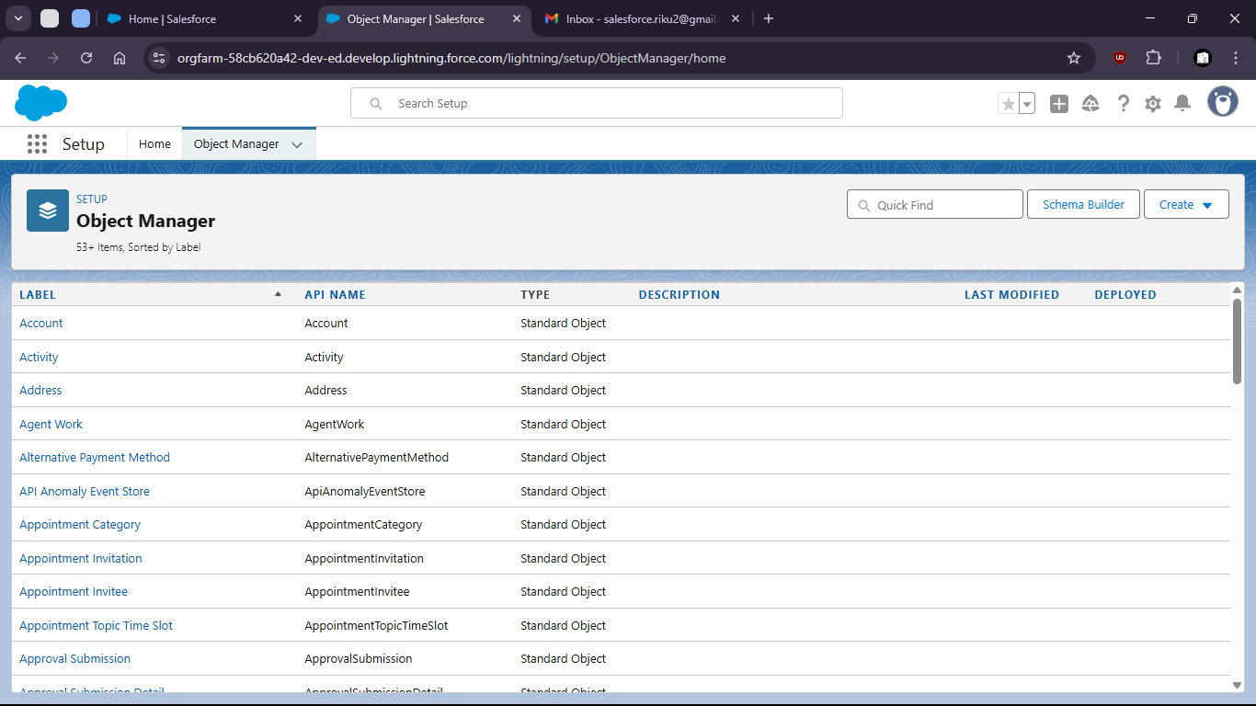

- select opportunity

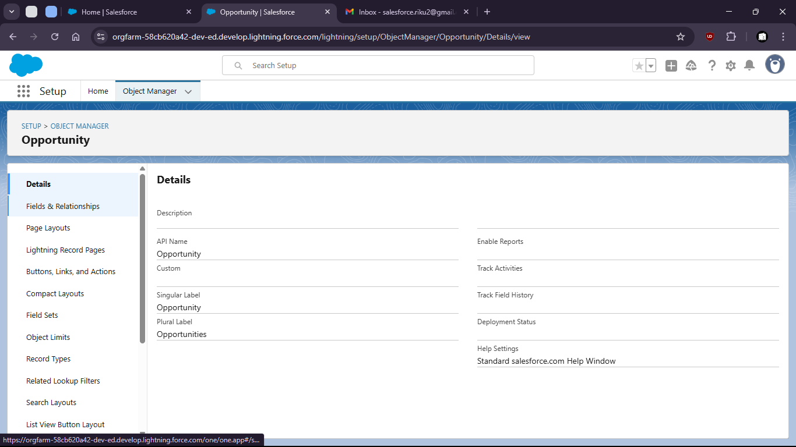

- Go to fields and relationships

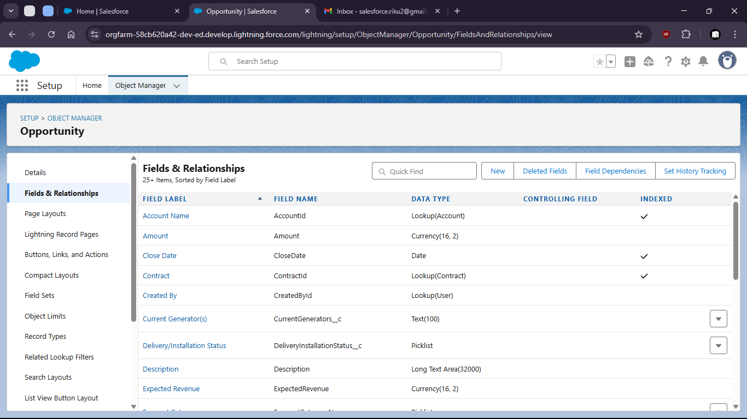

- Create new Field “Region”

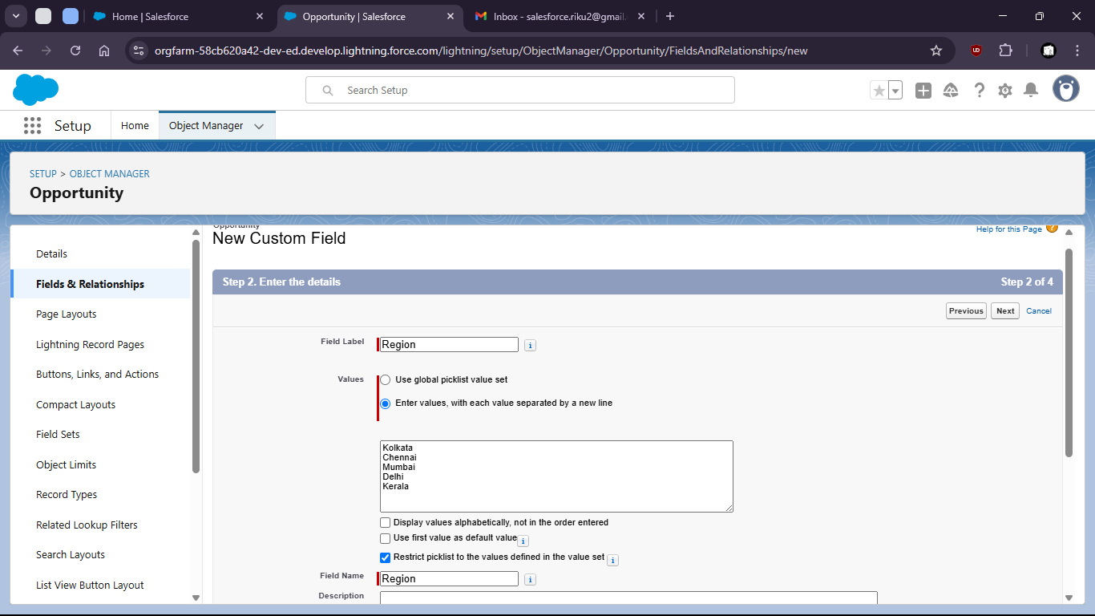

- Now search For Reports in App Launcher

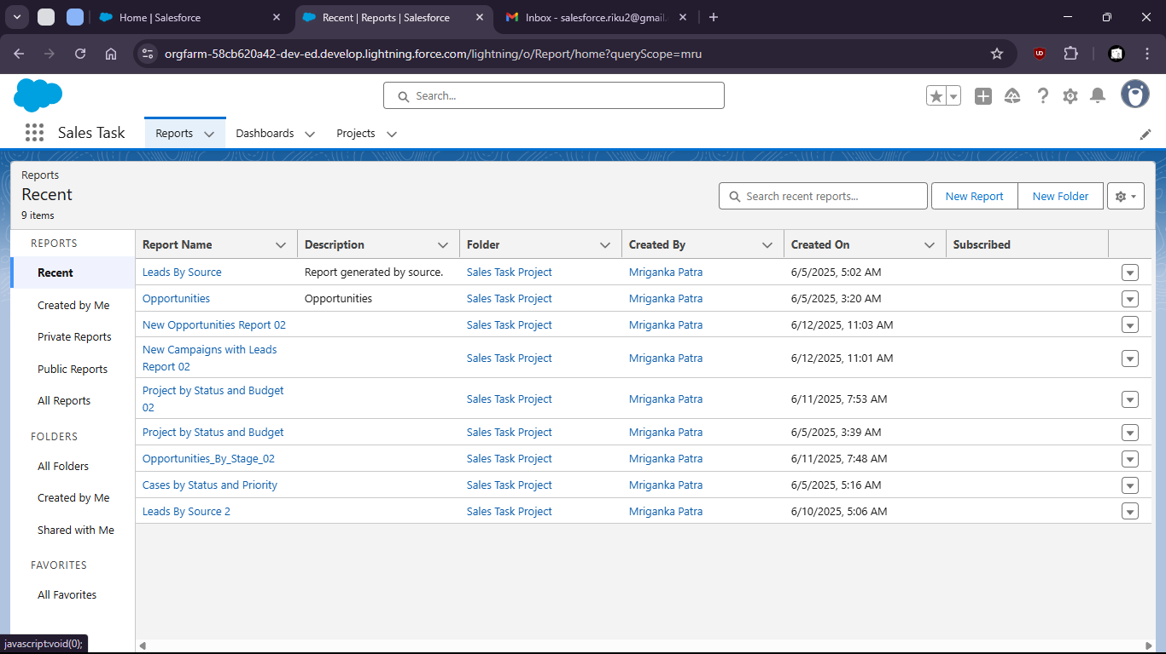

- Create new report on Opportunities

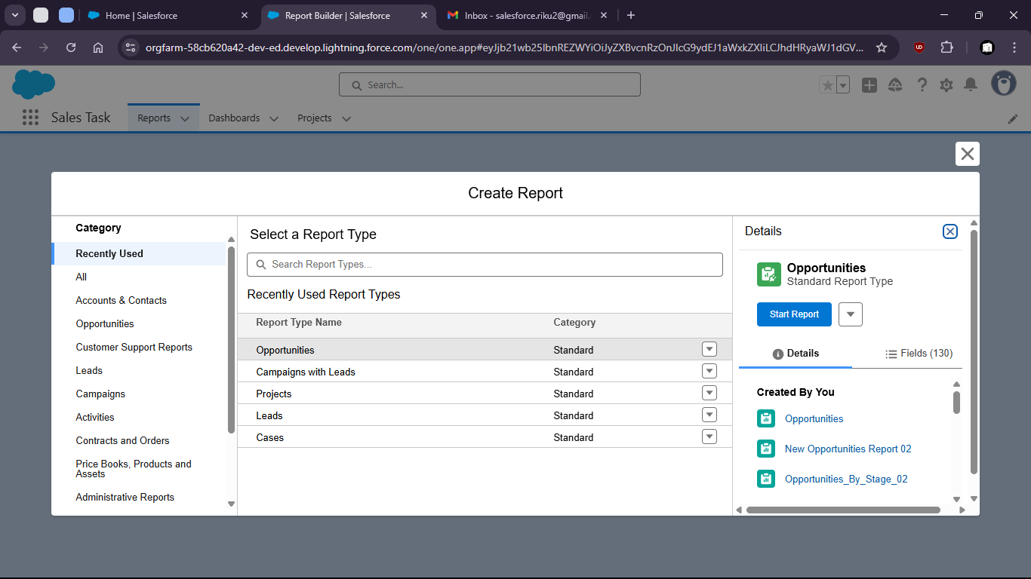

- Group by region

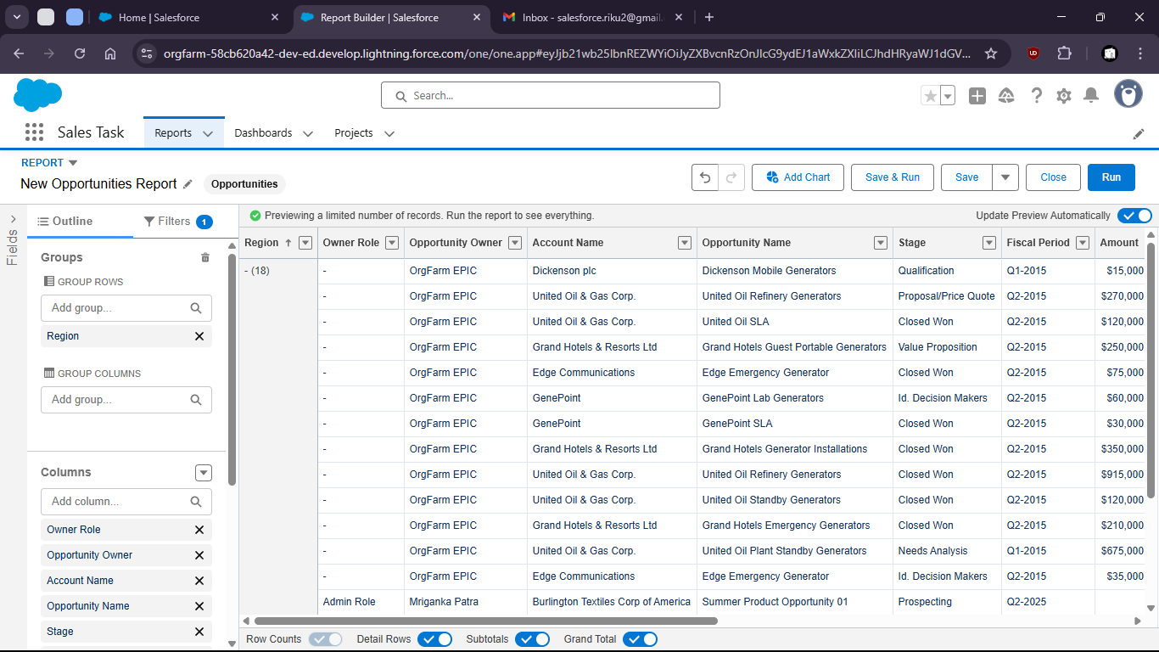

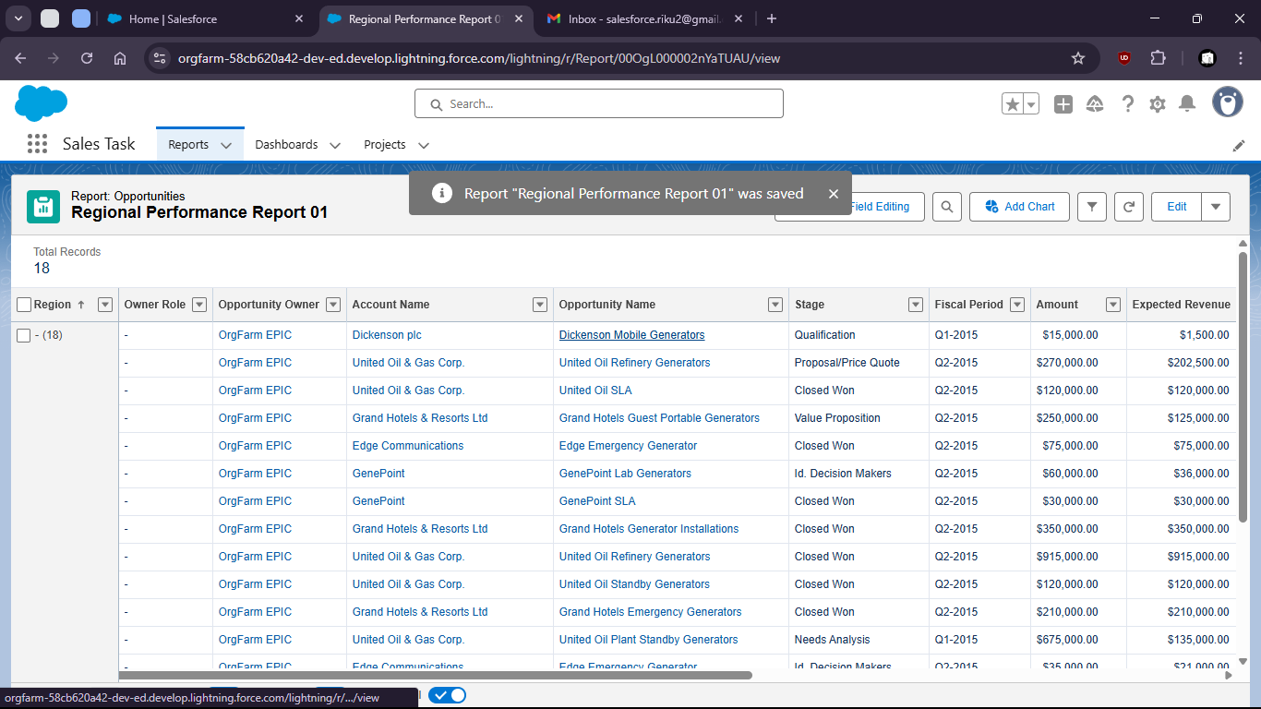

- Create new Dashboard on the Report

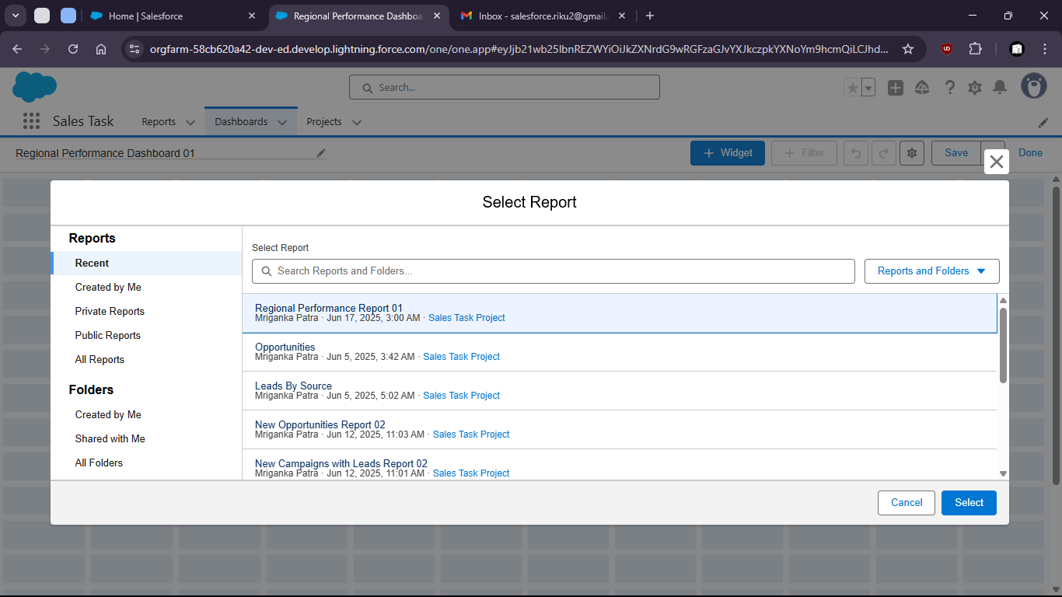

- Add widgets for better visualization

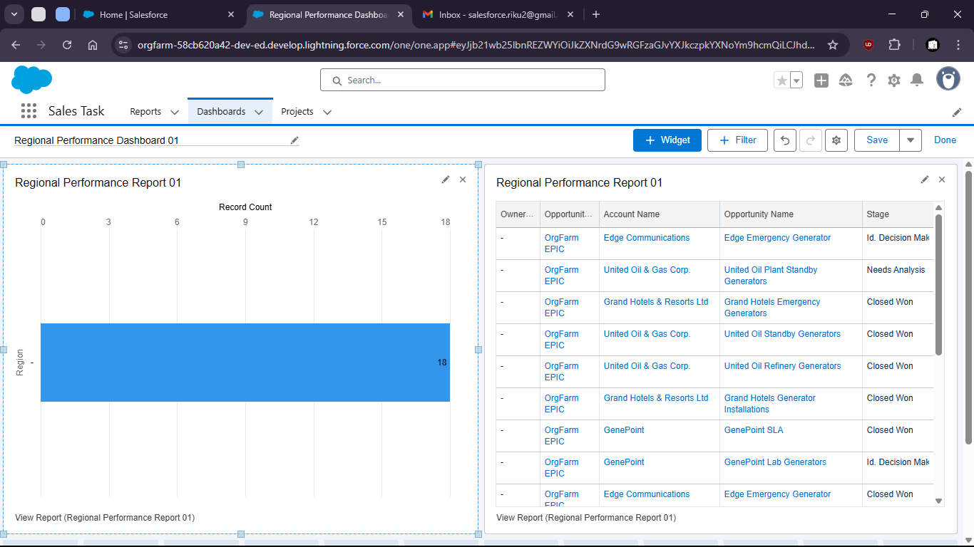

Task 1.7: As a system I want to auto-create an Opportunity when a new Account is added so that sales tracking begins immediately.

- Go to Setup

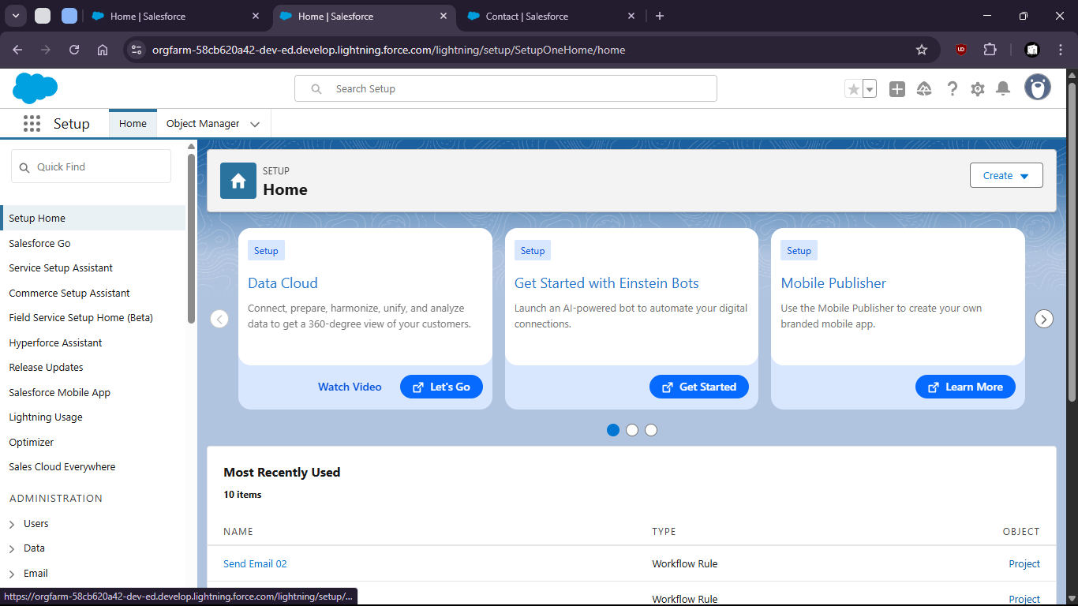

- Search for “Flows”

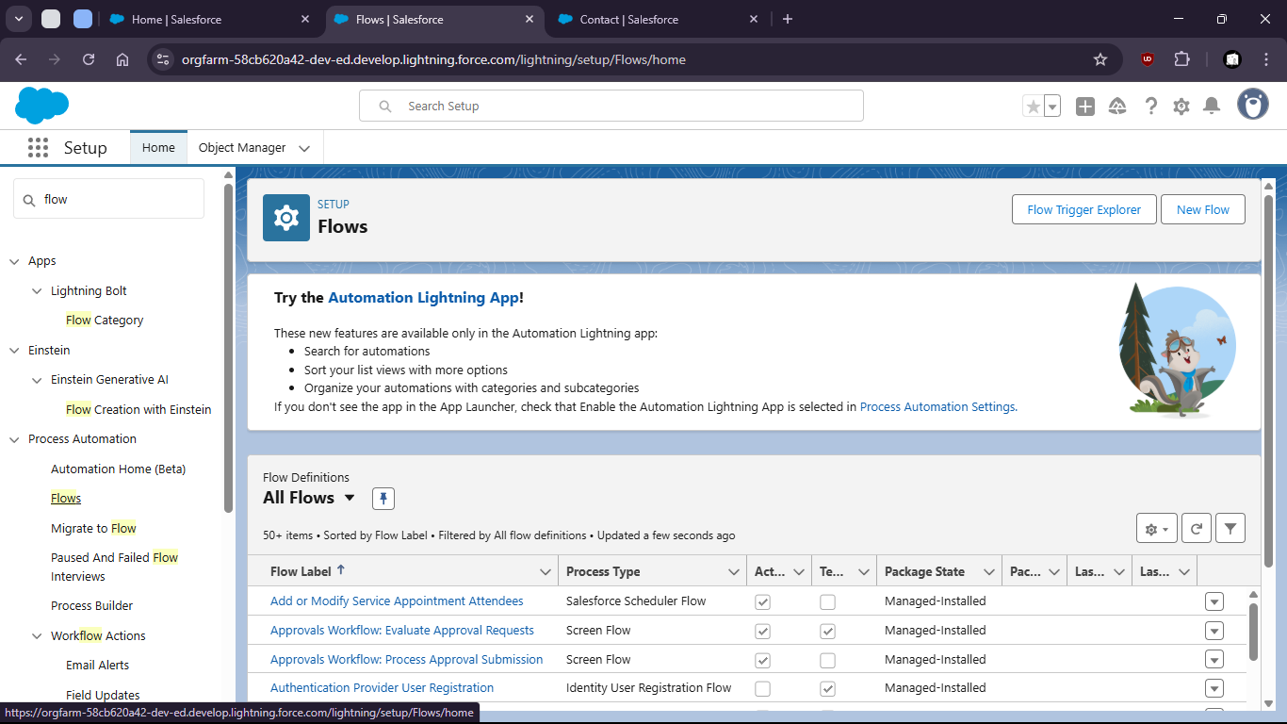

- Click new

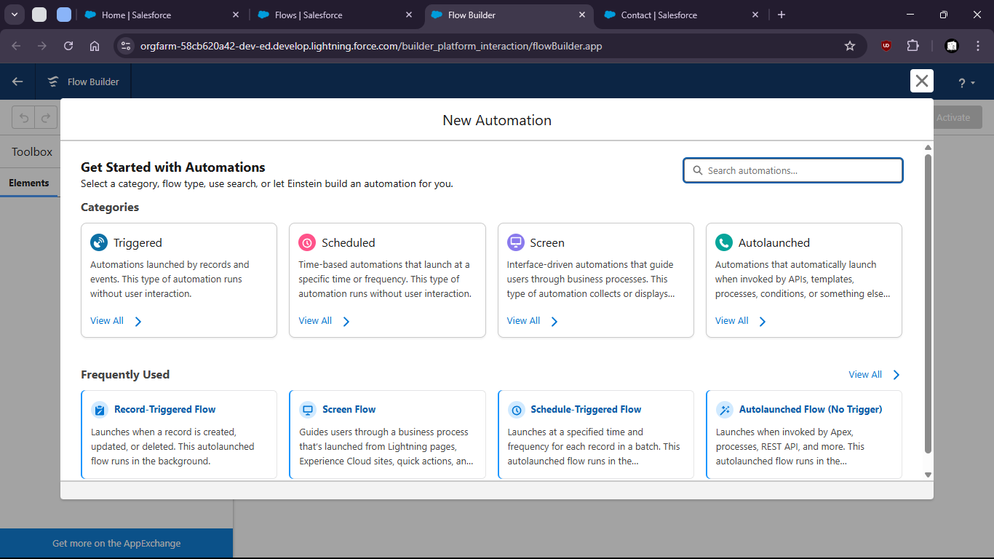

- Select Record Triggered Flow

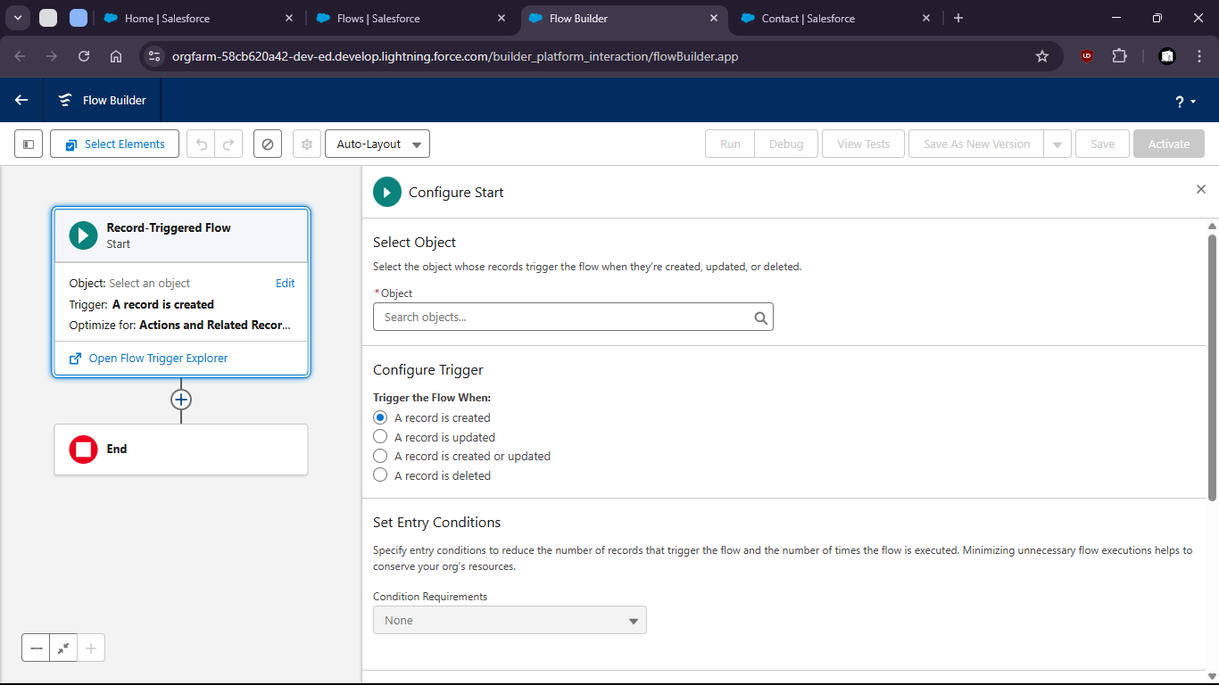

- Select Account as Object

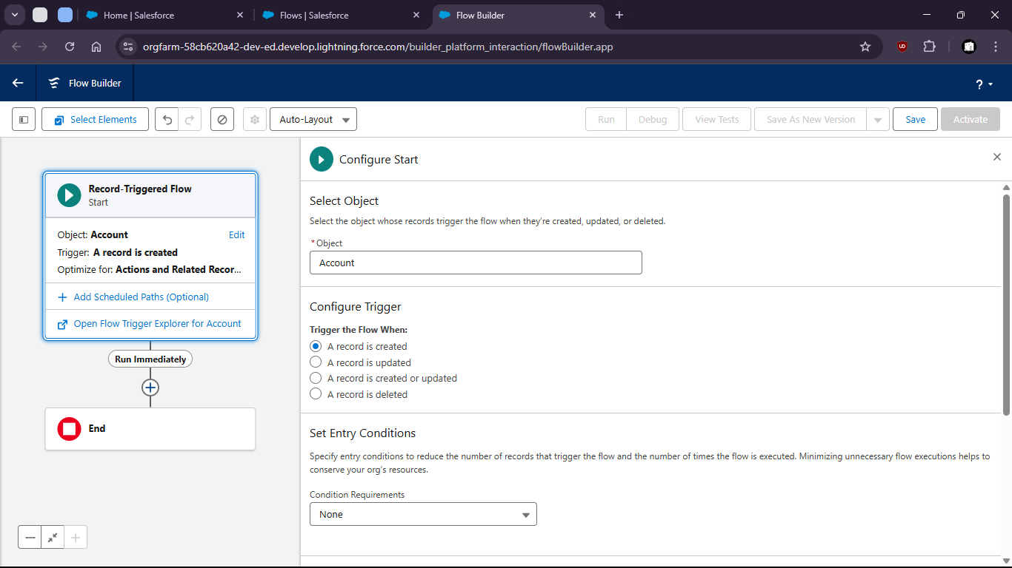

- Add Create Records Element

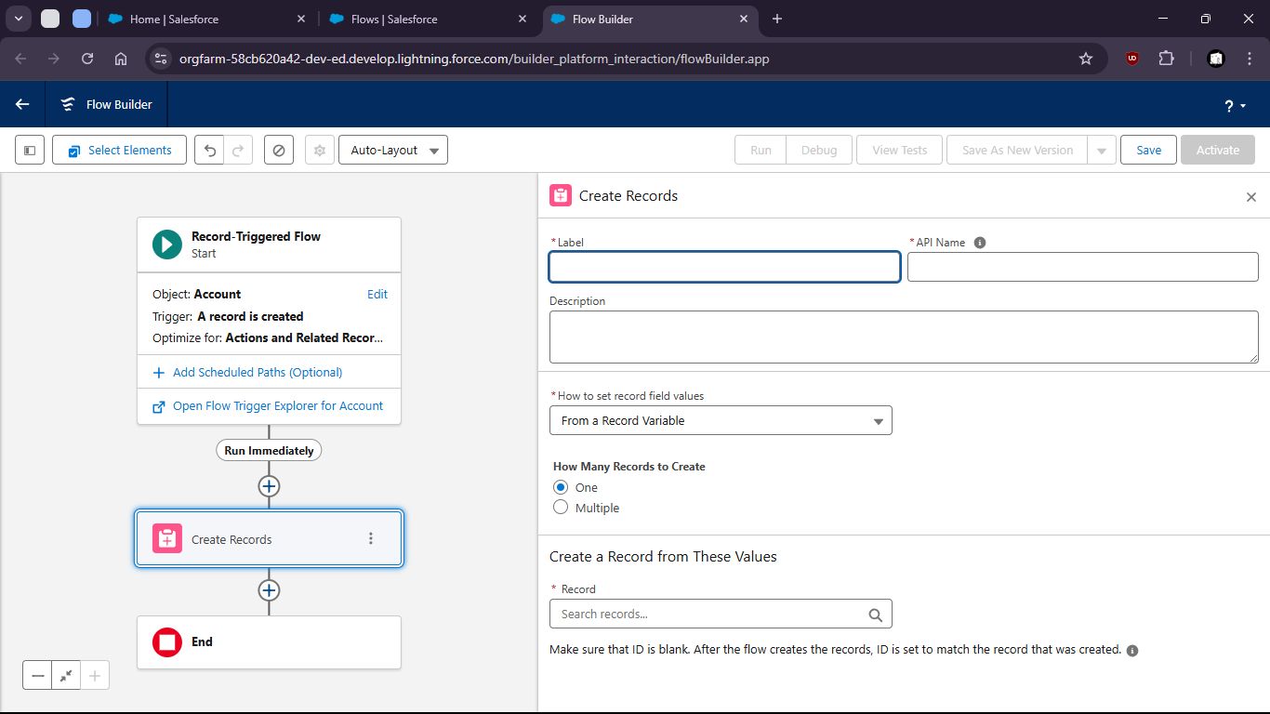

- Fill Up opportunity field values

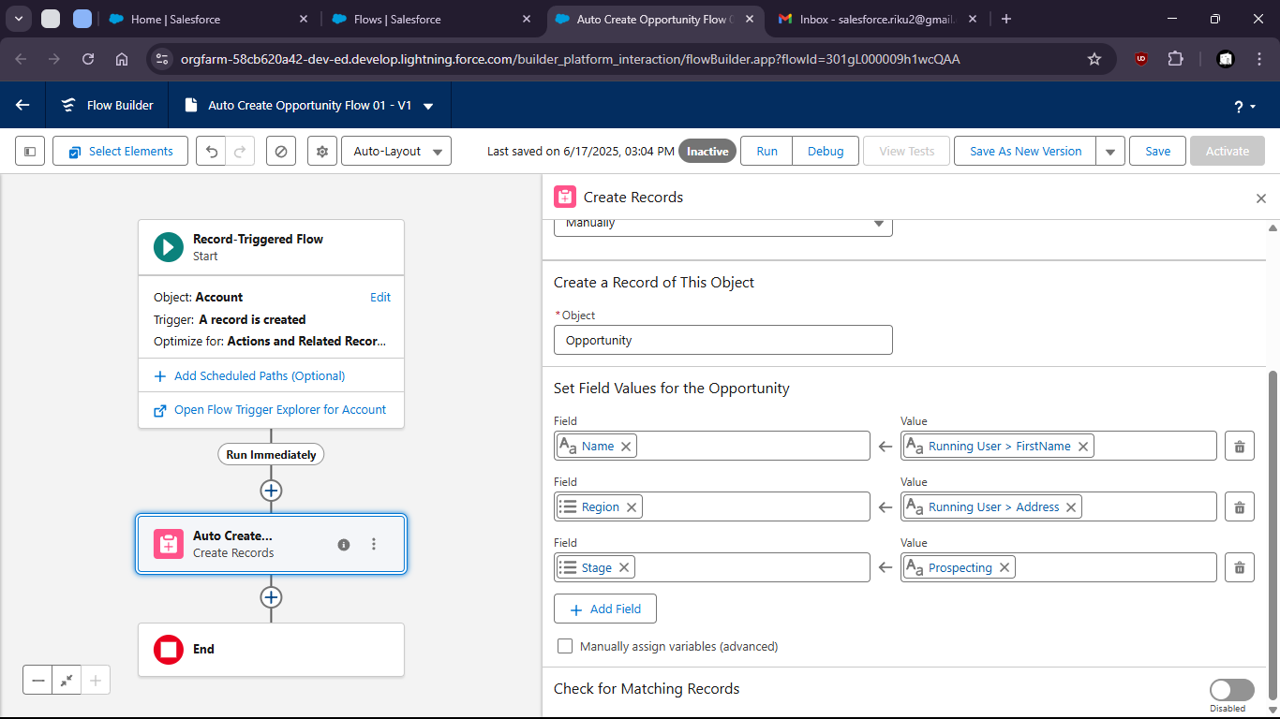

- Save and Activate

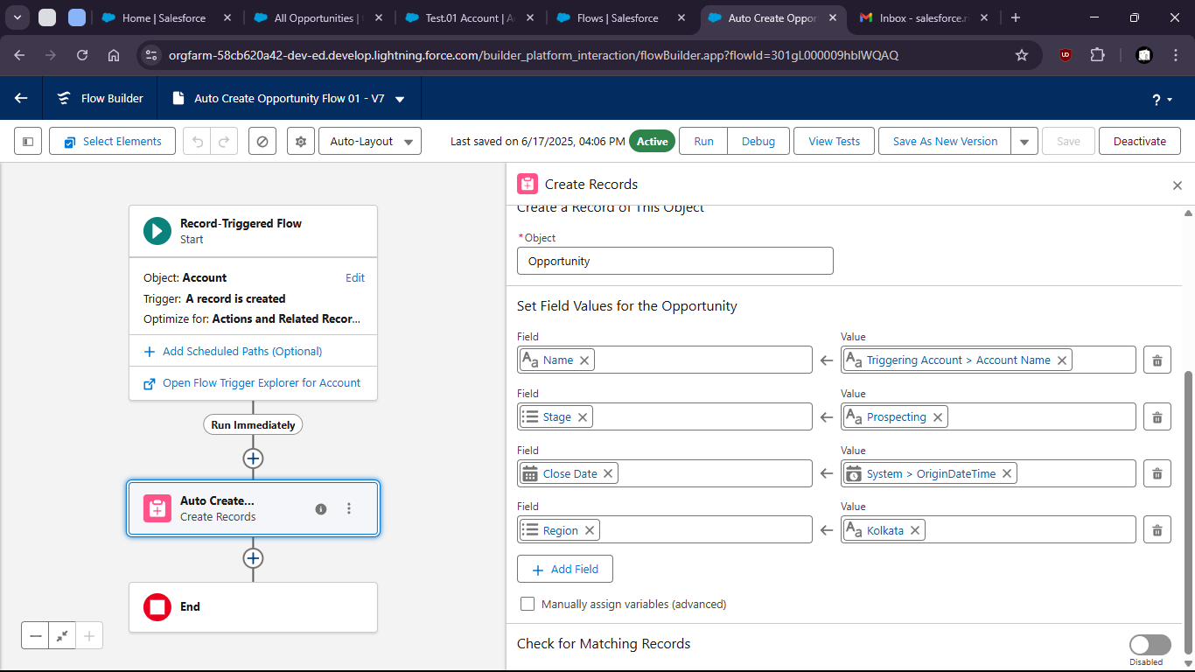

- Now to verify
- Crete a new Account (name: Test Account)

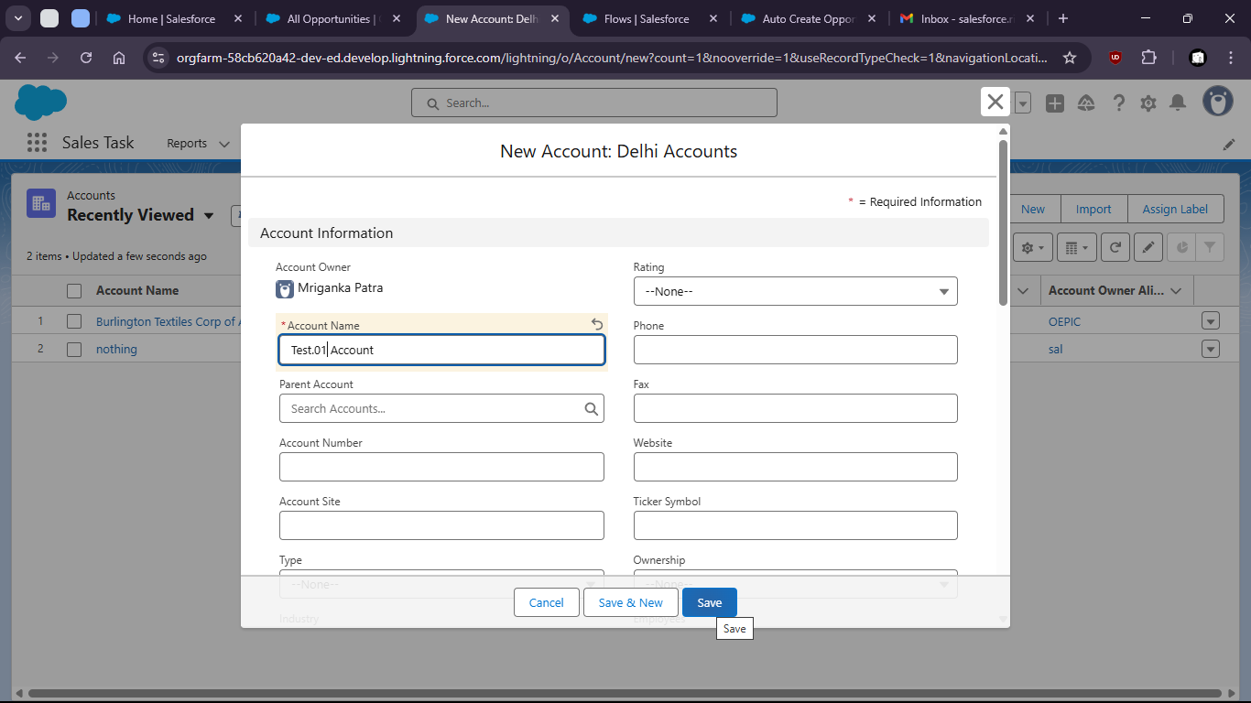

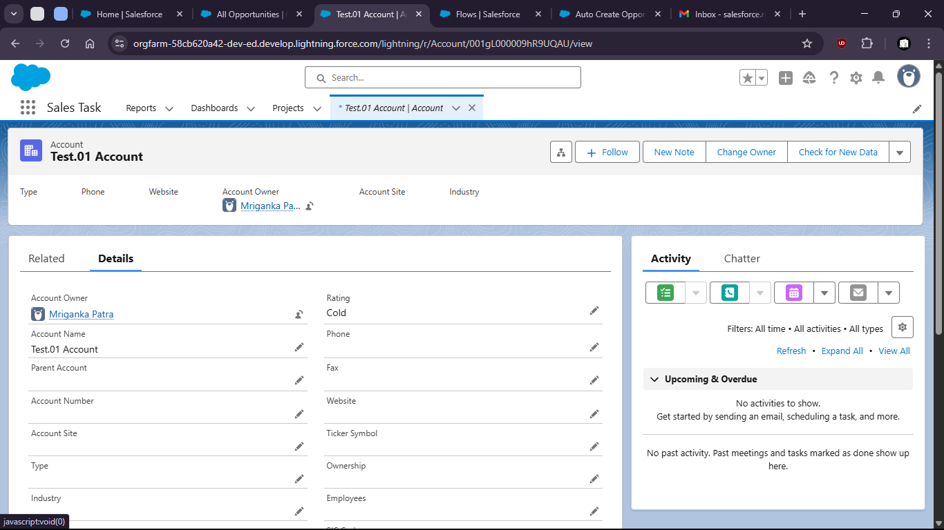

- We can check new opportunity was created

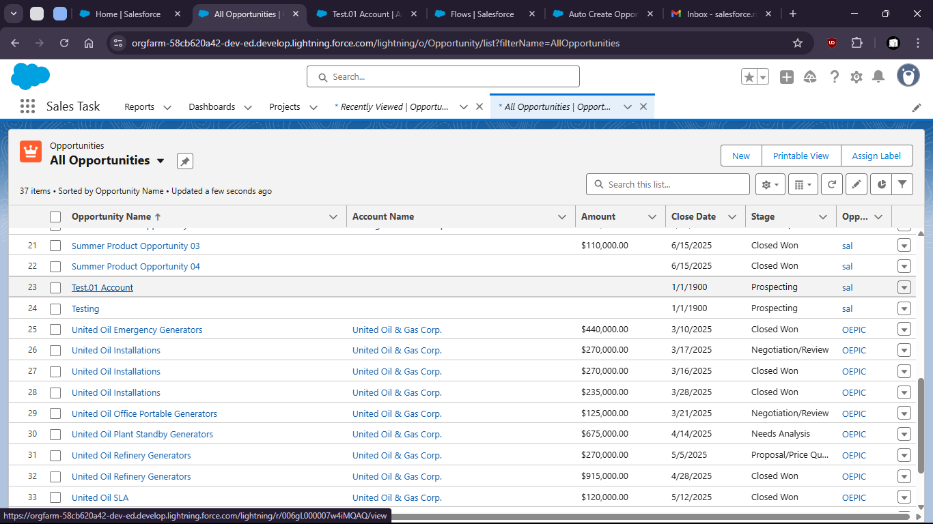

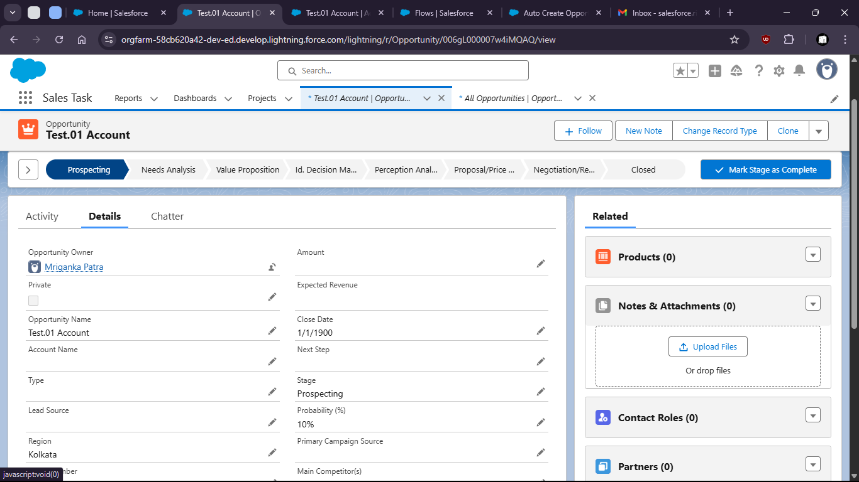

Task 1.8: As a System, I want to update fields based on predefined conditions to ensure data consistency.

- Go to setup page > Home > workflow rules

- 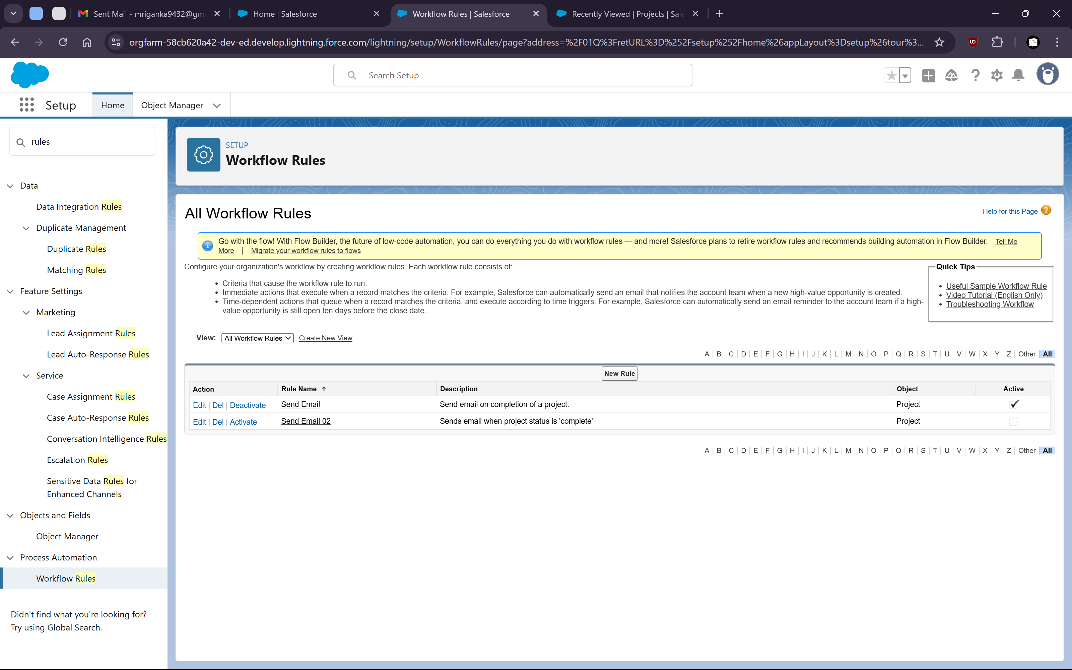

- Create Rule with Project Object

- 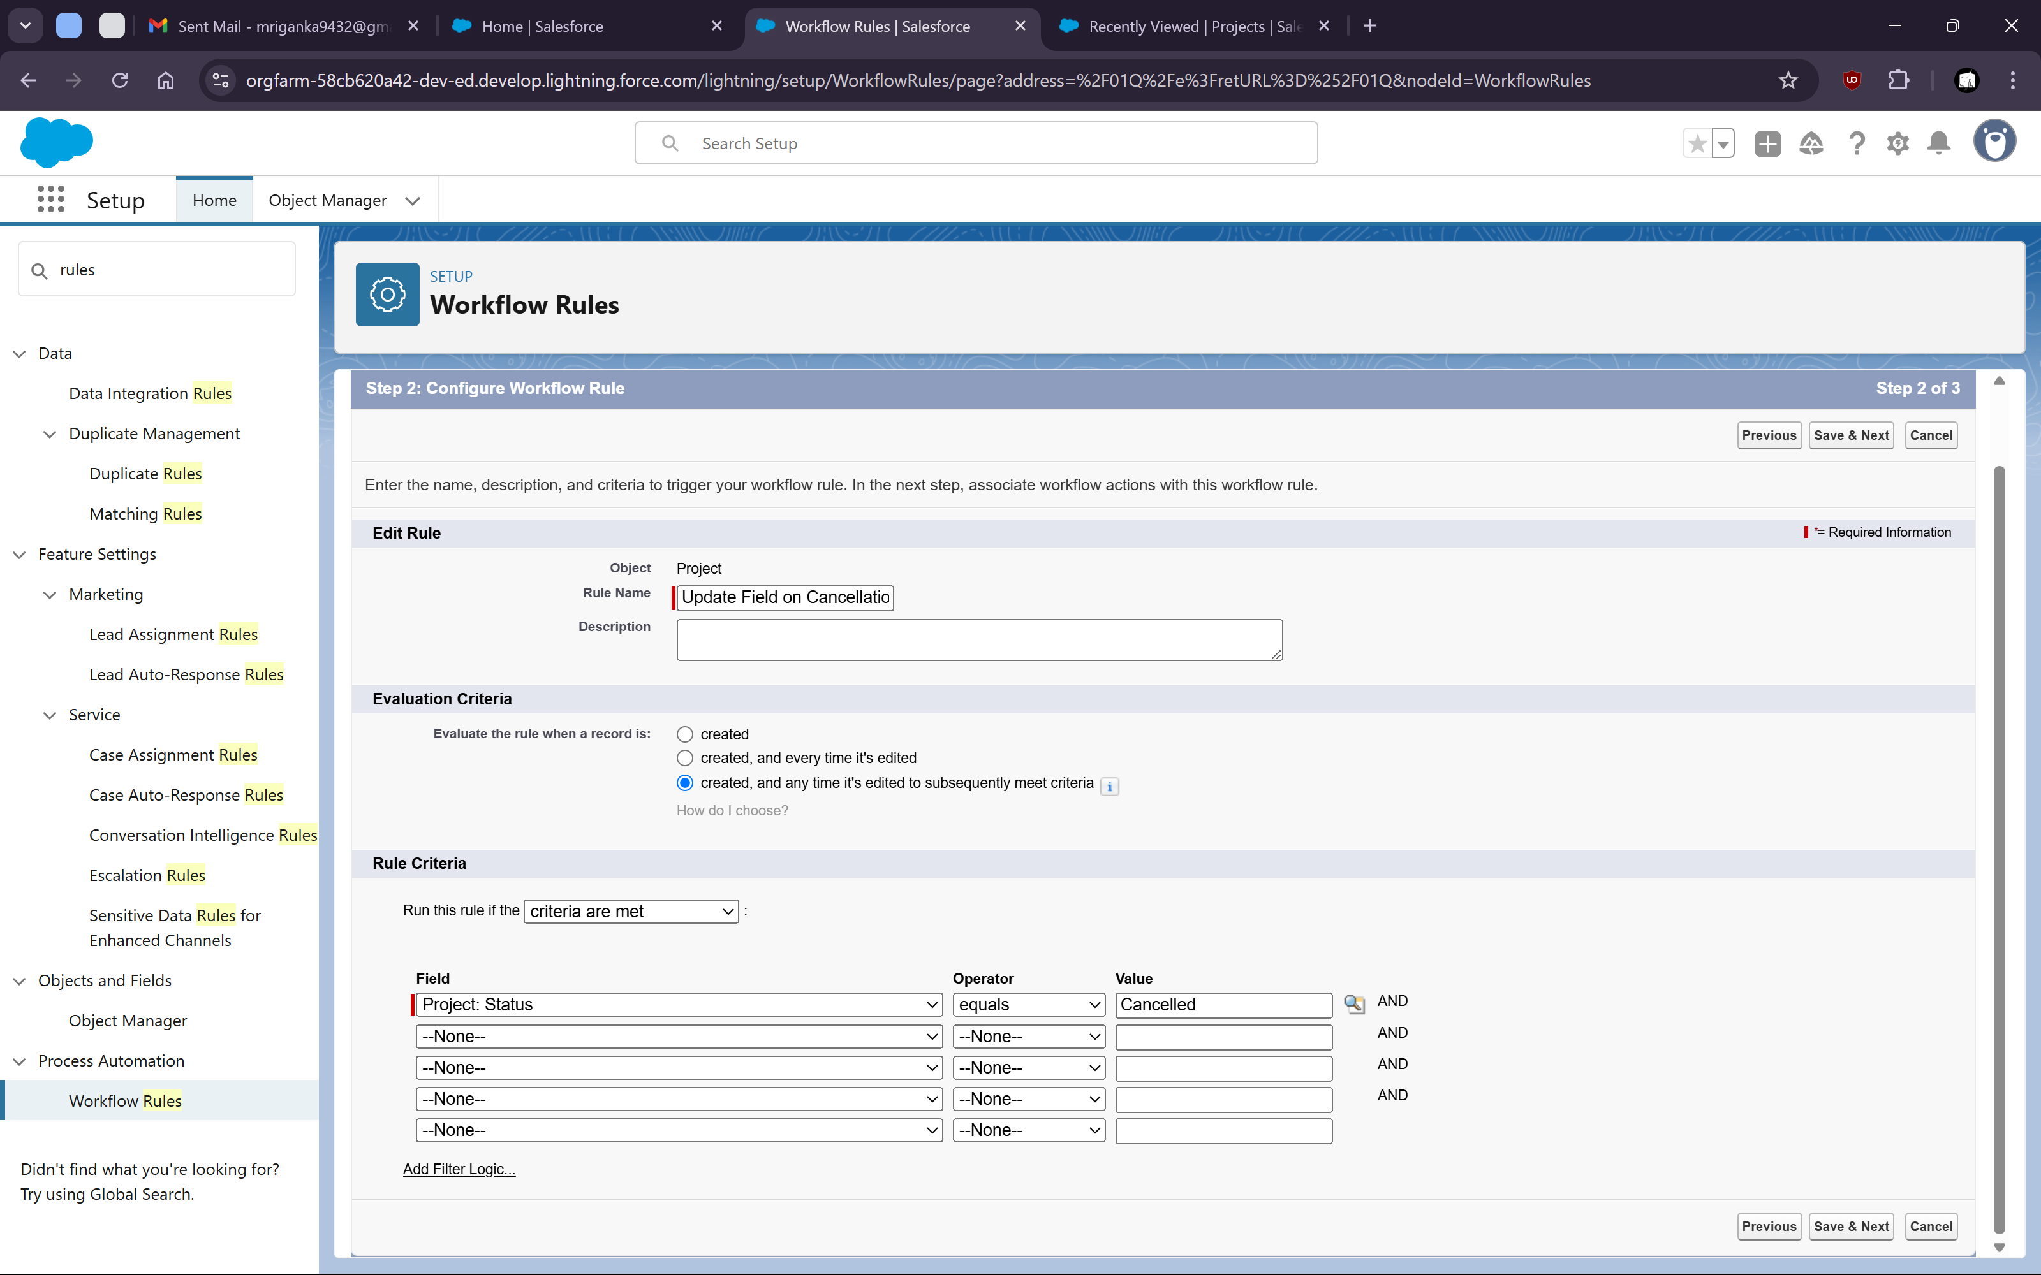

- Setup Blank Value if Project Is Cancelled

- 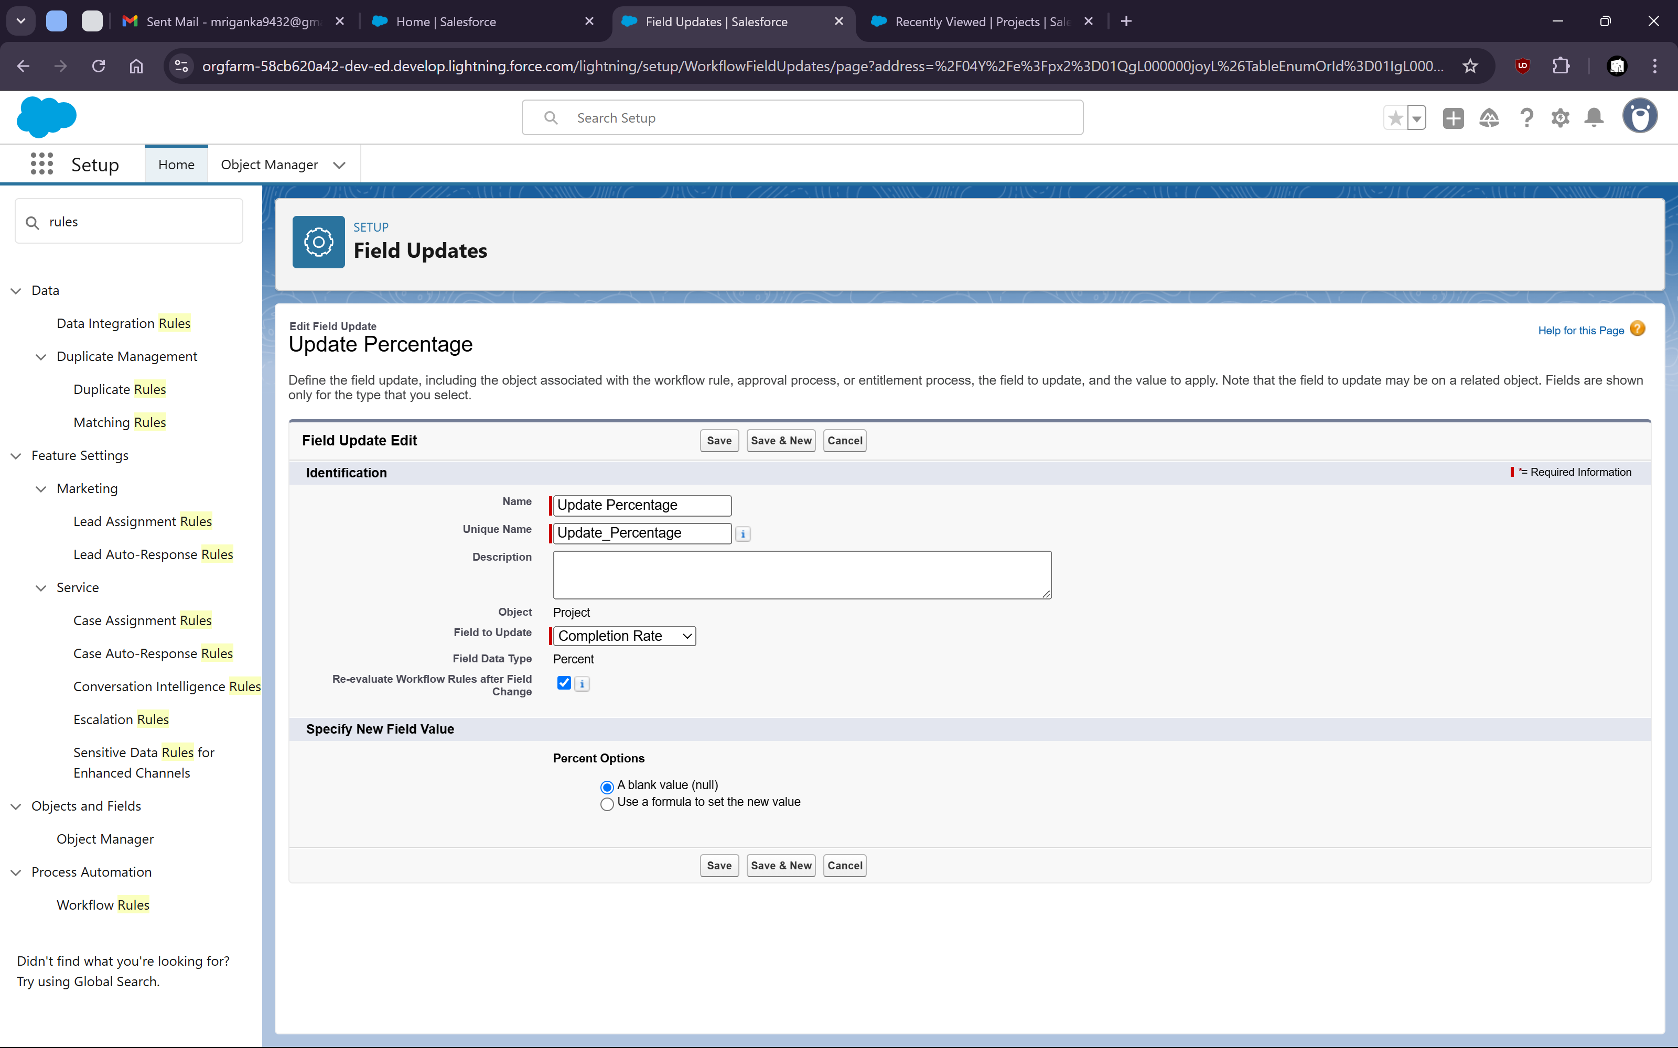

xiv. Now Activate the rule

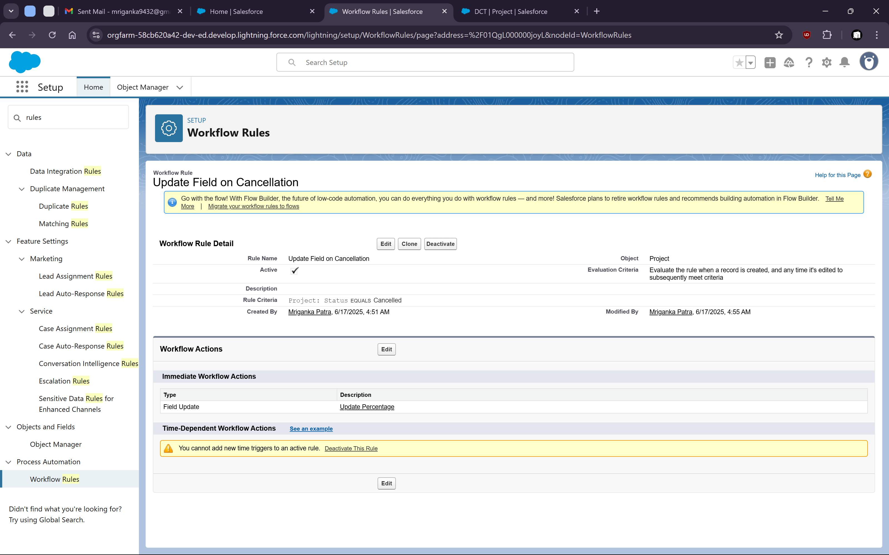

Xv. Now check if the rule is working or not

Go to one of the project where status is anything other than cancelled and the progress has a value

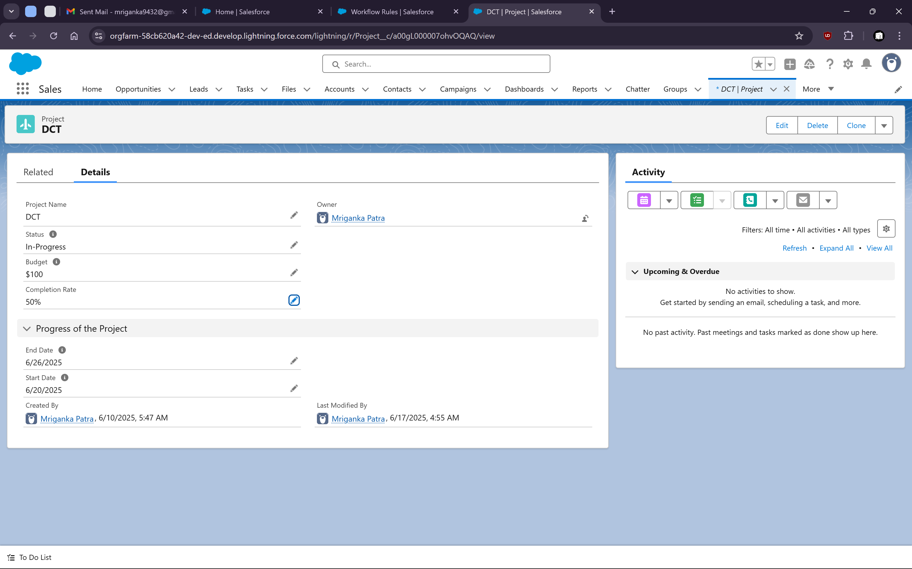

Now change the status to “Cancelled” and save it

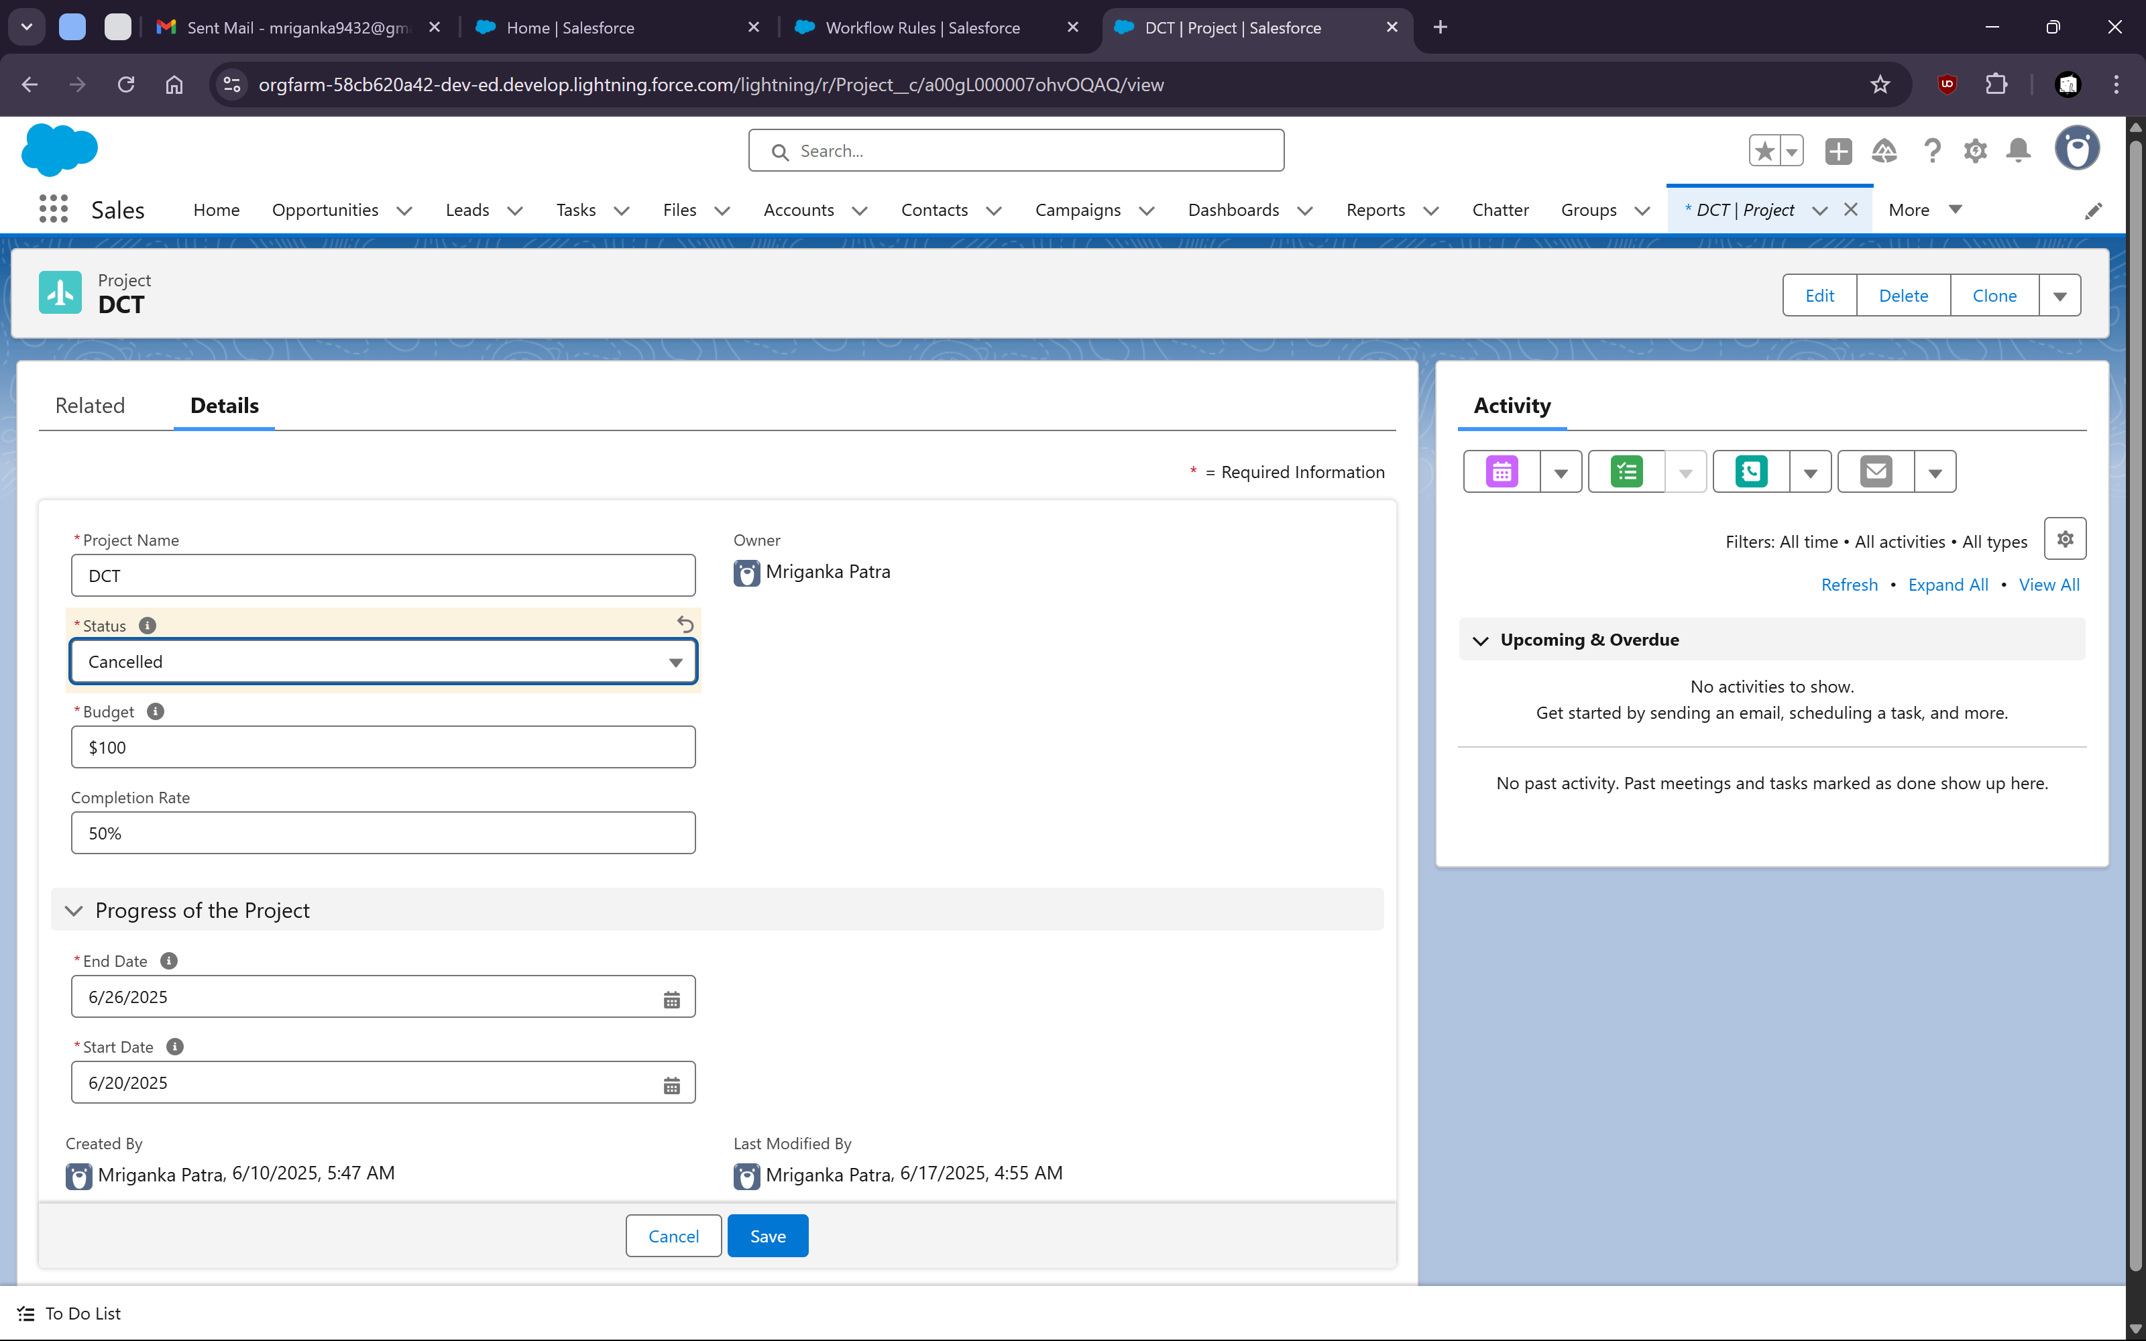

We can check that the completion rate gets set to NULL value after that

